DX SEO Migrations Theory

SEO Migrations
The vast majority of companies have web presence already. Either an ecommerce site, an institutional one, a blog, or a combination. So, when doing an ecommerce implementation, we´re typically in an SEO Migration situation.
Organic Traffic associated to those sites is always a direct or indirect contributor to the website and company´s revenue. Some companies directly invest in SEO to boost that revenue, some others grows “organically”, but the vast majority will definitely have Organic Traffic to take care about.
One of the biggest challenges when doing an SEO migration is the fact that most customers assume they don´t need it. They do. Period.

How to: SEO Migrations
The industry typically handles SEO migrations by considering an entire site and creating redirect rules (sometimes highly complex), or 1-1 redirects when not feasible, to achieve a perfectly executed migration. In addition to that, the content is considered at page by page basis – all of it: from meta data, to alt attributes on images, in-page content, internal URL structure, linking, linkjuice, etc which can only be tackled if its led by an SEO expert from day 0 of an implementation (from the planning).
There´s many other considerations, feel free to explore blog posts on how migrations are done by industry experts. Here are a couple, but we recommend reading others (search in Google for “SEO Migration guide” or “SEO migration checklist”):
- https://searchengineland.com/site-migration-seo-checklist-dont-lose-traffic-286880
- https://ahrefs.com/blog/website-migration/
- https://www.marceldigital.com/blog/the-ultimate-seo-website-migration-checklist#:~:text=An%20SEO%20migration%20is%20a,when%20conducting%20a%20website%20migration
The efforts for an industry standard SEO migration are, at minimum, 30hrs for an SEO expert or SEO Agency and depending on the complexity of the migrating website + the new platform´s capabilities (redirect rules? url structure possibilities? Automatic mapping? Regular expressions for content creation? Etc etc), the efforts on the customer side might be x3 or x5 of the consultant´s effort.
Most of the time, a website owner won´t have enough Organic Revenue to spend so much money and time on an SEO migration. But at the same time, they can´t afford the loss of the organic revenue of their current site (NOTE: This is the case besides if customer claims it or not! They just don´t know, especially the ones that grew up organically and didn´t spend direct money in SEO).

With the regular method:
Pros: 100% of the website and 100% of the SEO strategy and efforts are considered. The analysis is (mostly) atemporal and will not expire soon. It fits largest websites and largest SEO strategies with no issue. Requires SEO expertise but can be done by junior resources with a proper process and tools.
Cons: Time/money consuming, specialized tools are required (often expensive), needs to “be part” of the implementation itself (can´t be done ascync, needs to be done as part of the planning and execution), requires certain features which may or may not be available in the new website´s software/platform.

Context
At first, SuiteCommerce didn´t have SEO migrations considered. It was a customer task and responsibility at 100%.
What happened was: Customers didn´t know (and we must assume they don´t and won´t know) about SEO enough to realize they needed an SEO migration during their implementation. Those customers lost their traffic, which can´t be recovered by a rollback nor actions “after the fact”, and the revenue associated to it.
This led to customers complaining about SuiteCommerce being “bad” or “unfriendly” for SEO, which wasn´t accurate. They were losing money because of SEO, yes, but not because of the SEO capabilities/friendliness of the product itself.

Examples of what happens when a migration goes wrong:
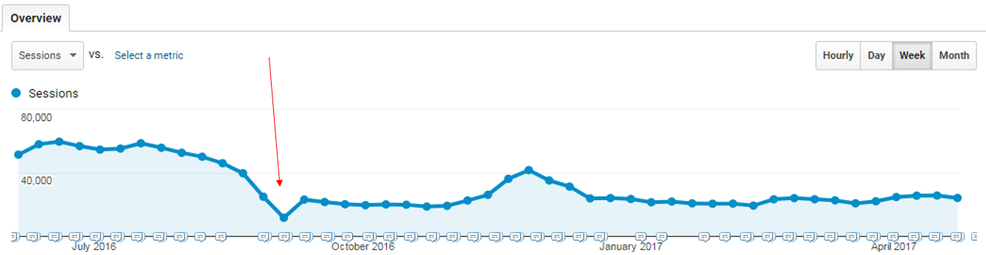
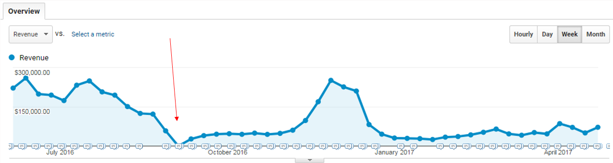

There´s no “recovery” after that. Only way to go back (if possible) to previous numbers is by spending money and time optimizing the website. That won´t take less than a year in best case scenario, and will consume x10+ the investment of a regular migration.
The Challenge
Coming up with an SEO Migration offering that: was affordable, repeatable, incurs in minimum customer efforts (at least compared to a regular one), doesn´t require advanced SEO software or tools, and could be executed as part of any implementation regardless of customer size.
SuiteCommerce and NetSuite doesn´t offer enough tools for an SEO migration to be done via “wildcard redirects” nor any sort of rules. So redirects must be 1-1.

Case Study
On a regular SEO migration, we should consider the following metrics: Organic Traffic, Organic Revenue, page and domain authority, inbound links per unique URL, content of each page (titles, descriptions, heading tags, text, images and their alt and title tags, meta tags like canonical among others), URL structure, internal linking structure, linkjuice of individual URLs, revenue per URL, direct and indirect contribution to goals per URL, etc etc.
Former DX Manger, Diego Gallo, ran a case study where he analyzed multiple SEO migrations and its results to come up with a combination of up to 3 metrics that could be utilized to come up with a game plan.
After analyzing how different metrics (and combinations of metrics) behaved after a migration, we identified that “Entrances” (Google Analytics metric, filtered for Organic Traffic only) met all the requirements to be utilized for planning an SEO Migration under certain circumstances, and only when those are meet. That was the case for 90%+ of the SuiteCommerce customers, but there´s still a 10% that might require other approach.

GA Entrances: This metric represents the entrance page (relative URL) of a visit. If we apply an Organic Traffic segment, we have the list of pages through which the users are accessing via Organic Traffic on a given timeframe.
The use-case:
- As part of the case study, one of the conclusions was that we have to utilize a 6 months timeframe for a non-seasonal website and 1 year for seasonal websites.
- Around 15% of the URLs of a site, will capitalize +95% of the website´s organic traffic
BUT: that 15% of URLs will fluctuate, is not the same 15% all the time. This leads to the biggest ballpark of using this metric: it has an expiration date. It’s a snapshot of a specific period, and must be captured as close to the go live as possible.
- As a conclusion: There´s an expiration date for the snapshot: 3 months.
  - Note: It was lately extended with “minimum” impact, to 6 months due to pushes on golive dates. NOT IDEAL, though.
- Given that multiple factors are left behind, there´s a need for a critical and specialized eye to be “behind the scene” while doing the analysis to catch any potential deviation that might cause this method to fail.

With this method:
Pros: The analysis is less time-consuming, customer efforts are way lower, no need to use SEO-specialized software (beyond Google Analytics, which isn´t an SEO software and most sites have), results in +95% of traffic preservation. The platform limitations of SuiteCommerce for SEO migrations (no wildcard redirects) won´t limit us.
Cons: The method doesn´t cover all factors by the process and its assumed that an expert will be running it to use its expert eye to identify situations where a site may require another approach. The analysis is a snapshot which expires after 3 (to 6) months and so it requires proper golive planning. There´s too much information to consider and typically too many projects to run in parallel. No room for mistakes.

Beyond SEO Migrations
Beyond the migration itself, SuiteCommerce has some characteristics that makes it unique (negatively unique, to be honest) from an SEO standpoint.
Those characteristics comes from one factor: SuiteCommerce is a single page application.
Single page applications aren´t crawlable by Search Engines nor other bots, by default. There´s a need to have Prerendering technology behind the scenes which makes SEO testing way more complex for a non-expert.
In addition to that: most tracking tools and third party (digital marketing) services will not be compatible with a single page application by default – there´s a need to “customize”.

The Conclusion
DX Offering includes all that´s required for our implementations: The SEO Migration with the “quick” method, the tracking and third-party tools done by SMEs, and checkpoints to make sure the product (and the migration)

SS4C, Custom SC & SCA Engagements:

SS4C and other Implementations:
SS4C projects will contain 9 DX hours while some SC/As will have 10 – the only difference is the amount of customer interactions and internal coordination we might expect.
Those hours are divided in:
- 5 hours for Migration Analysis and Tracking tools integration
- 2 hours (3 when there´s 10 hrs) for Pre Go-live Checkpoint
- 2 hours for Post Go-live Checkpoint
CPM will engage DX following this process. Once you get a project assigned, make sure:
- You´re assigned to the job and the task, with the right number of hours
- Include the project to your OpenAir´s Forecast.
- Ask the CPM to provide you with NetSuite backend access

Forecasting:
- For ease of planning, you should forecast the 5 hours 4 weeks before going live. 2 hours the week before the go-live, and 2 hours the week before the go-live.
- Ideally, you should be engaged at least 6 weeks before the go-live to properly plan your forecast, especially under periods of low bandwidth.

SuiteCommerce My Account (SCMA) Engagements:

SCMA Projects:
SCMA projects will contain 3 hours for tracking tools implementation and testing.
The CPM should ask the customer if they are interested in installing tracking tools and third-party services (from the supported list). If the customer is interested in integrating some service, CPM should create an engagement task for DX.
The DX resource will contact the customer to know which services have to be installed and then will integrate them.

Forecasting:
For easiness of planning, you should forecast the 3 hours the week of the go-live,
Ideally, you should be notified 3-4 weeks prior to that go live in order to properly plan your forecast. Especially under periods of low bandwidth.

-- This is the end of “Processing an Engagement” &
all things associated to work process --

Migration Analysis

There´s two paths which opens other options into them:
- Open Site (this includes “login to see prices” and fully open sites). Lo hacemos únicamente si tiene un sitio anterior.
- Closed Site (a fully password protected site. In this case, you can´t even see the home page without login). No hacemos migration analysis en este caso, solo DX Action List.
Casos:
- Puedo estar haciendo análisis de un sitio nuevo, y el sitio de implementación, puede ser igual al final domain, por ejemplo: fpp.partsmidwest.com que es password protected
- Puedo estar en el caso de migrar un sitio que no es SC www.abrimagery.com, y pasa a ser SC en el mismo dominio, entonces el current domain es www.abrimagery.com (Not SC) y el final domain es www.abrimagery.com (SC)
Open Site:
Once again there´s more than one option: It might be a brand-new site, a migrating site (which can also be divided into: Single site migrating to Single site, multiple sites merged into one, or a single site split into a new one).
Brand-new Site: The customer don´t have a website or has one that won´t be migrated into NetSuite´s ecosystem (BE CAREFUL to capture the requirement correctly!)
There´s no initial traffic analysis, but we do verify by ourselves that there´s no existing site that will likely migrate to NetSuite (again, capture the requirement correctly and double check it with your eyes). So, we jump directly into the Tracking tools integration.

Migrating Site: The customer is migrating an existing website/domain to our platform.
There´s two paths on running the migration analysis:
- Customer has Google Analytics: Migration Analysis must be done with the data coming from GA.
Note: Customers and Consultants may not know if they have GA or not. Check by yourself and guide the customer and consultant thru.
It is your job to make sure all things possible to follow this path!
- Customer doesn´t have Google Analytics nor an equivalent: We do it by scraping Google´s search results.
Customer has Google Analytics:

Step 1: Initial assessment
Check if you got the GA access correctly (ID matches the ID that´s implemented in the migrating site, there´s a view with no filters, you got the right access type).
If customer has GA4 and you have at least a 3 months of data, use GA3.
If the customer has just installed GA4, use GA3 at least for following month. Following month if customer has just installed GA4, use OScraper. (https://confluence.nsgbu.netsuitecorp.com/display/~brady.onkka/Google+Analytics+4)
If OScraper has significantly better data (GA4 has 50 or less hits and Oscraper has a few hundred or more) then we use OScraper
Create your folders:
In Local, you should have a structure like: Work/Customers/PS and Work/Customers/ACS. Create a folder into it with THE WEBSITE´S NAME (to avoid future confusions). IE: /Work/Customers/PS/MyCustomerSite
The following files must be added to the folder (there´s going to be guidance as to how to get those files as the project progresses):
- Google Search Console verification file (which can be obtained into Google Search Console´s account, later on post go live).
- “Robots.txt” file. This can be utilized as a backup during post golive checkpoint.
- “GA_projectname.xlsx” this is the file containing the dataExport from Google Analytics. This is a template file that will be overwrite afterwards.
- “URLs to 301 – projectname.xlsx” this is the migration analysis file which we´ll explain below. This is a template that you´ll be working on afterwards.
- “projectname Redirects.csv” the file with the final redirects to be imported to NetSuite during the go live.

In Google Drive (drive.google.com), you structure must look like: MyDrive/Analysis/PS, and into it you should create a folder per website (not per customer, but website).
The files you´ll host into that folder are allocated into MyDrive/Templates (these are ORIGINAL files you should never edit).
Select the files: “Template Initial-Pre Redirect Checker”, “Template Post Redirect Checker” and “Template Redirects”.
Make a copy of those 3 into your customer´s drive folder, and edit the names to replace “template” with the customer´s name. IE: “MyCustomer Initial-Pre Redirect Checker” and so on.

Step 2: Migration Analysis
- First, we start by doing an overall quick analysis of the migrating (current) website. If we find something abnormal or information that wasn´t provided (be sure this will be the case, pay attention), ask the consultant or customer for clarifications.
With Abnormal we might be speaking about:
  - Find a valid subdomain that we weren´t told about. IE: sprigusa.com is the customer´s website, but during the analysis we found shop.sprigusa.com which we weren´t notified about.
In this case, we need to ask the customer what site are they migrating – or if they are planning to unify both into a single site/domain.
  - Check for a Blog and see if it’s hosted either separately or on a /blog structure. If the blog is separate (different domain or exclusive subdomain) we recommend to keep it without migration. If its /blog or similar, there´s dozens of possibilities including the site being completely different (even tho hosted within the same domain) and have its own tracking tools (which means we need different accesses to analyze the traffic that goes to it).
We ARE in charge of the migration of a /blog as well so make sure to pay attention to every detail.
  - Those were JUST EXAMPLES and you must use your critical SEO eye to identify others.
  - Check for example.com, www.example.com, store.example.com, shop.example.com, opc.example.com
- Check how many Indexed URLs the site has in Google
  - Open new Incognito window (this is: close all incognito you have, and open from scratch. Pay attention to “window” vs “tab”). Set it in english.
  - On the search bar, type “site:” followed by the (sub)domain you need to check (it has to be their current site, which we are going to migrate, the one that has google analytics data).
    - Do not use “http://” nor “https://”
    - Do not use trialing slash (IE: www.example.com/ vs www.example.com this second one is the right one to use)
    - Make sure to be checking the right (sub)domain. www and root are “one thing” so if you´re checking www, check the root.
    - Valid examples:
      - site:www.example.com
      - site:example.com
      - site:shop.example.com

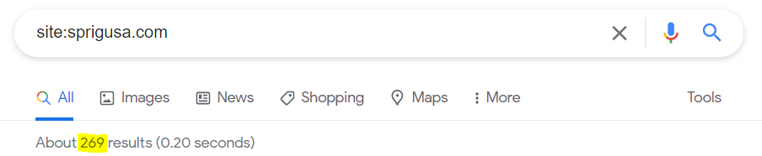
Important, do it on incognito window and in ENGLISH

Now we are going to check if to use GA3, or GA4, or OSCraper.
I need to go to admin -> “Property change history” for both GA3 and GA4, and if the creation date is close to today, means they have not used GA3 and GA4 before. Then I need to choose OSCraper to do the analysis. If only creation date of GA3 is close, I need to use GA4 migration analysis from Chris and Brady confluence’s page
Google Analytics 4
https://confluence.nsgbu.netsuitecorp.com/pages/viewpage.action?spaceKey=~brady.onkka&title=Google+Analytics+4+-+Migration+Steps

When using GA4 as the Migration Analysis Source, please use the following steps:
- Log in to the customers Google Analytics 4 account
- Click on Reports:
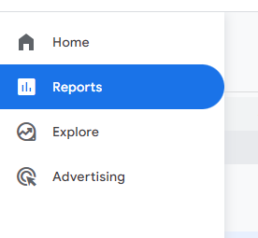

- Once in Reports go to Life Cycle > Acquisition > Traffic Acquisition:
  - We then click on Add comparison:
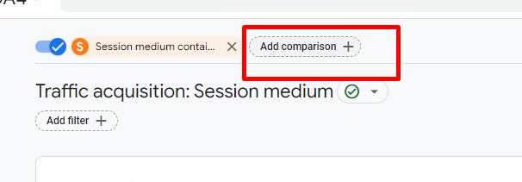
  - Then it will pop up a window, were we select:
    - Dimension: Session Medium
    - Match type: contains
    - Value: organic
  - And then we press apply
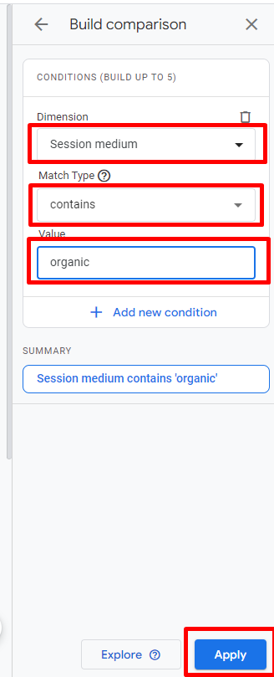
- We then should remove All Users. This will leave us with just organic traffic. To do this, press on “X” next to “All users”:
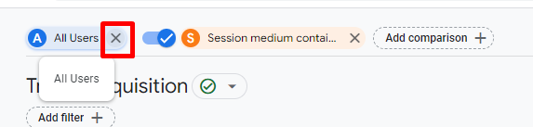

- Next step is adding a filter to limit our search to the specific domain of the site. For that, we press on “Add Filter”:
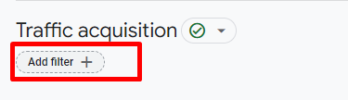
- And it will pop up a window just like before, were we select:
  - Dimension: Hostname
  - Match type: contains
  - Value: our domain, for example Equigas.net
- And lastly, press “apply” below. See figure:
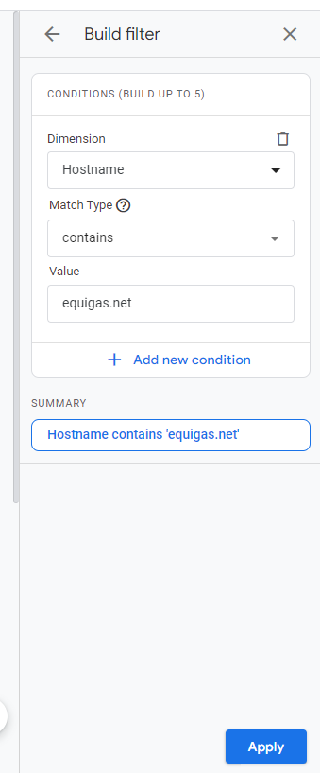
- Adding this filter will make sure we are pulling in the correct values for the job in question as GA4 can now accept data from multiple domains.
- Once all filters are added, we now need to add the URL that is generating the traffic. For this, we scroll down until we get to:
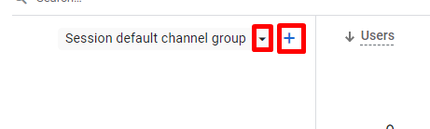
- There, we change “Session default channel group” for “Session medium”.
- Clicking on the blue plus will allow us to add the landing page and query string to the report. This is what we used to pull from GA3 and will give us the page the customers are landing on (what they clicked on from Google Search). Then, click the blue plus button:
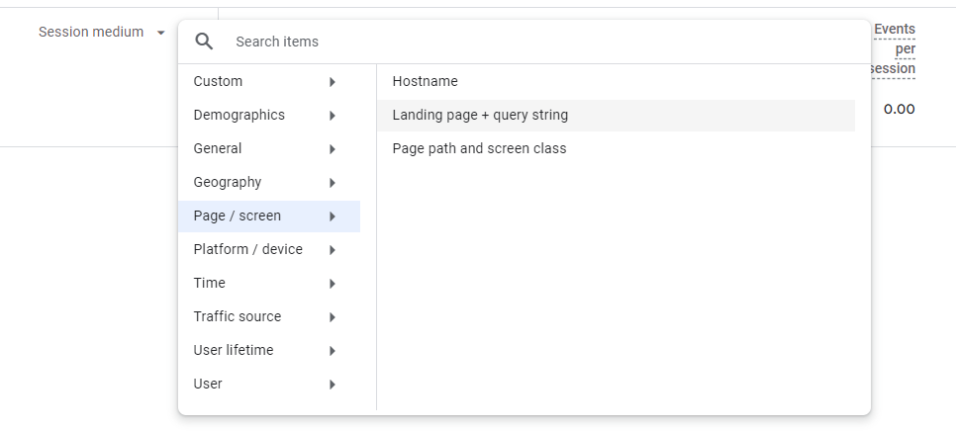
- Select “Page / screen” then “Landing page + query string”
- Once all traffic has been restricted, its time to determine what timeframe to export
  - This can be done by clicking on the date field showing at the top right of the page:
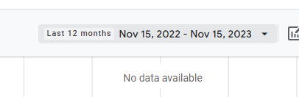
  - This will pop up the following window:
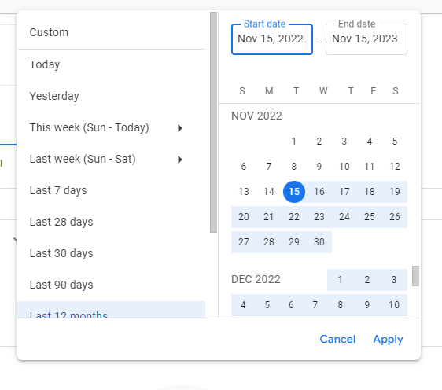
  - Here we need to select the timeframte for migration analysis. The two options to utilize are 6 months or a year.
    - How do we identify which one should we use:
      - Select 3 years and see how traffic behaves. If there´s an obvious seasonality spike yearly, we should use a year. If the traffic is mostly “flat” (there´s a pattern that repeats either weekly or monthly but there´s no “high ) then the traffic is not seasonal and we should go for 6 months instead.
- Once determined the correct time frame, we need to do the export of the report. To do this, we press on “Share this report”:
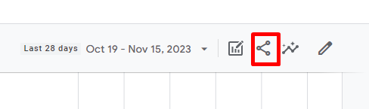
  - Then a window will pop up on the right, we select “Download File” and then “Download CSV”:
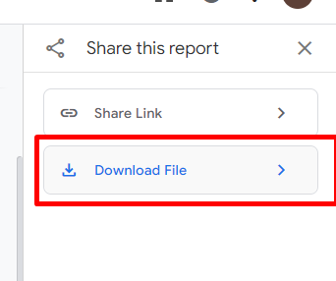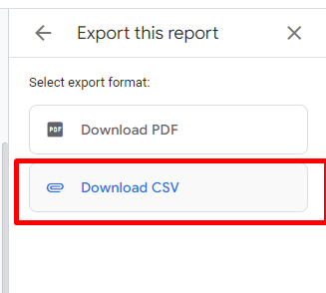
- We will get a fille downloaded called data-export(1).csv. If we open this one, we can translate that “Entrances” equals to in GA3 = “Sessions”

Google Analytics 3
- While running on VPN, Go to Google Analytics (analytics.google.com), browse to the customer´s account and make sure you select the right Property and the right View (property = website, view = unfiltered view which is typically “all website data”).
  - Go to: Behavior – Site Content – All Pages
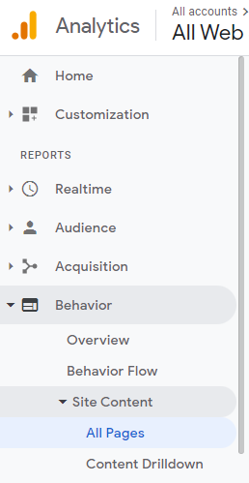
  - Apply the Segment “organic Traffic” (and remove the “All Users”, there must be only one: “Organic Traffic” selected)
Desmarco all users:
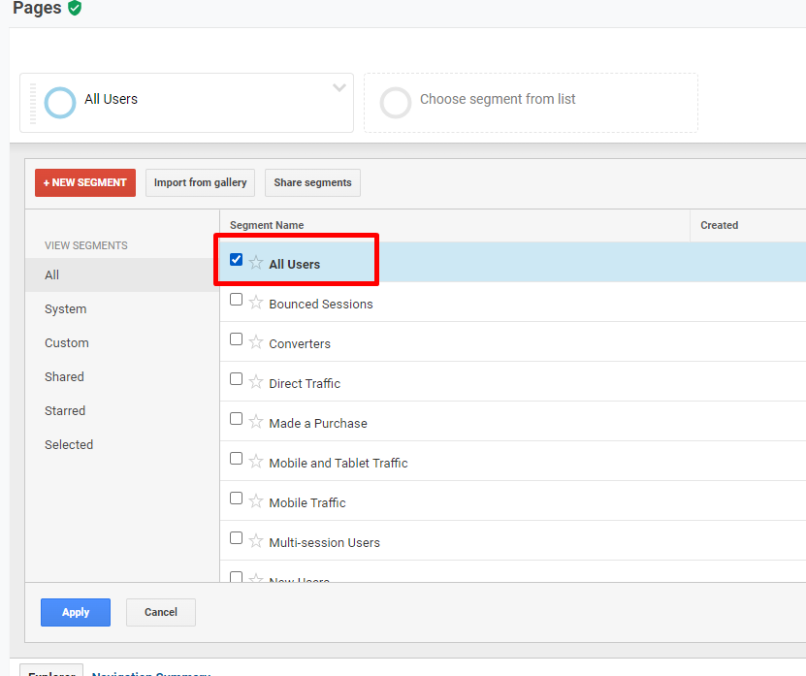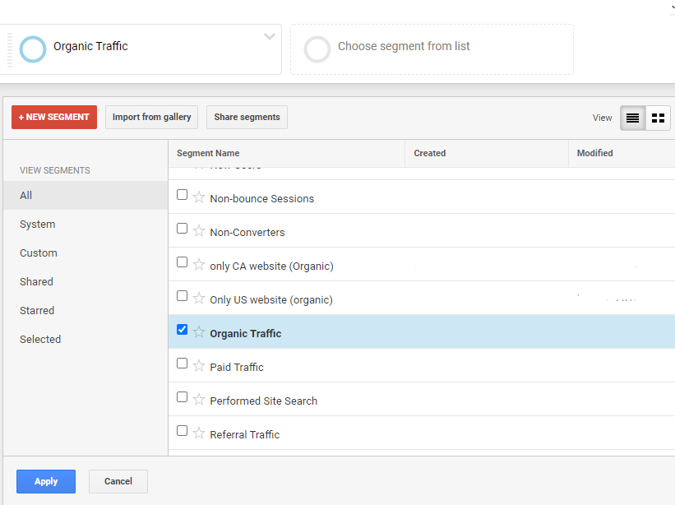
  - On the dropdown that manipulates the Chart, replace “pageviews” by “Entrances”
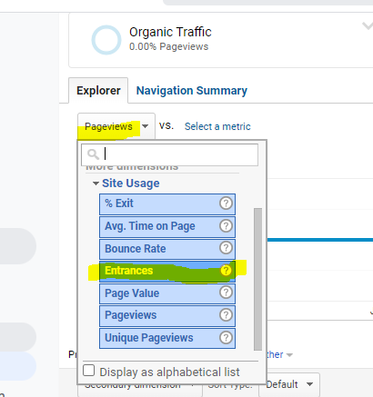
  - We need to select the timeframe for the migration analysis now. The two options we utilize are: 6 months or a year.
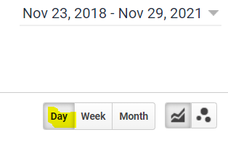
    - How to identify which to use:
      - Select 3 years and see how traffic behaves. If there´s an obvious seasonality spike yearly, we should use a year. If the traffic is mostly “flat” (there´s a pattern that repeats either weekly or monthly but there´s no “high ) then the traffic is not seasonal and we should go for 6 months instead.
In the example below, we can see how traffic goes crazy up on August and January – which means there IS seasonality in this business:
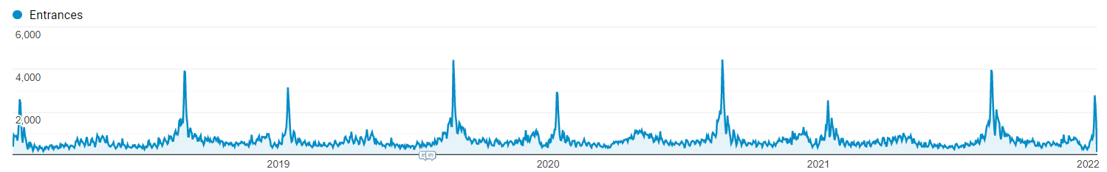

      - Once we identified if there´s seasonality or not, we select 6 months or a year (the example above: year).
  - Our Primary Dimension by default is “Page”. We must go ahead to add a secondary dimension “Hostname”
This helps us to identify which other domains or subdomains (if any) are being tracked with the same property/view and let us filter out whatever we don´t need to consider, focusing only on the (sub)domain we´re going to migrate:
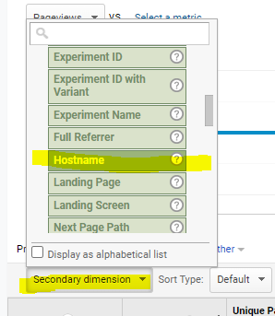
This also helps us to clear out repeated urls under misconfigurations (IE: Customer has the same URL on root and www, tracking both but under a different hostname – this is an incorrect configuration and otherwise we would get duplicated URLs in our report).
  - Now we apply a filter, selecting “Hostname” as the dimension and “Exactly Matching” as the rule: put the current website there, example shop.naturchemstore.net
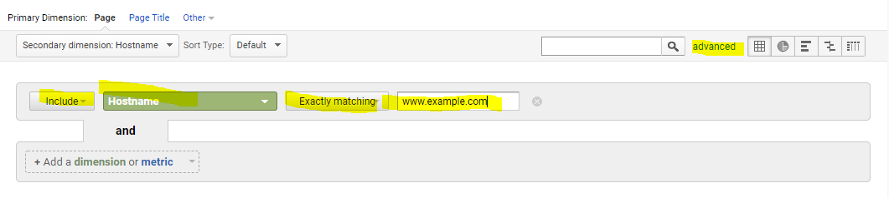
  - Once all that is done: proceed to sort by “Entrances” (major to minor)
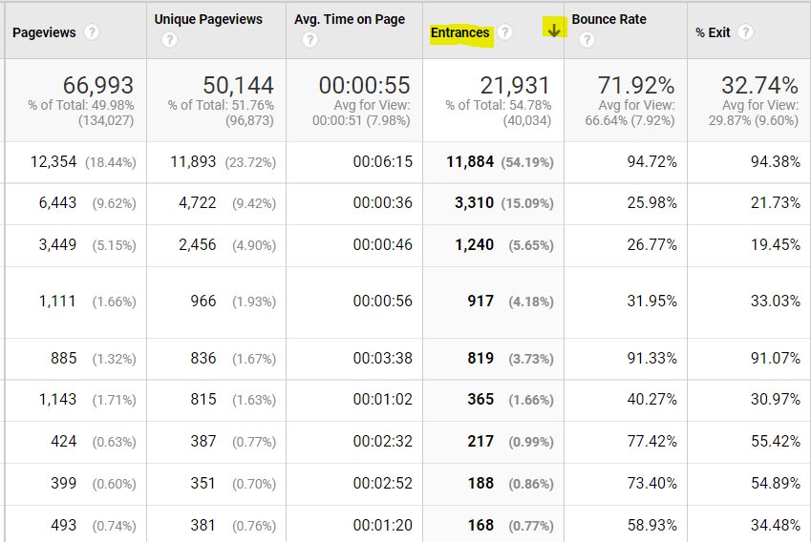
  - Set the “Show Rows” to the maximum possible. Google Analytics export will only export the Rows you´re seeing in the screen, so if you leave the default it´ll export only 10 Rows (10 URLs)
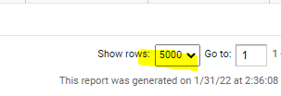
NOTE: there´s a chance that you have to run two exports if the site is really big, given that the maximum is 5000 URLs per view.
  - Last step is to export all this information. Hit the Export button on the top right screen and select “Excel (XLSX)”. Save this file to the customer´s folder you have created locally, replacing the “GA_projectname.xlsx” file.

Migration Analysis File for GA3 and GA4

- Migration Analysis file
  - Open the “URLs to 301 – projectname.xlsx”
    - The file is blocked for edits for security. Go to Review/Unprotect Sheet (pass: 123456)
    - The file has templated data loaded into it which you´ll have to clean/replace with your project´s information
    - On the first tab:
      - Change customer´s name and project on cell B2 (type it, don´t copy paste)
      - Change the domain on D6. It MUST MATCH with the domain you´re running the traffic analysis on. (Es decir, el dominio actual que usamos de GA)
        - Note: it mustn´t be hyperlink so make sure you´re removing the link if that happens automatically.
        - Mustn´t contain http nor https
      - Remove the Total Entrances value (E6)
      - Remove pages and entrances
    - On the second tab:
      - Delete the list of Old and New URLs
    - SAVE the file now, after completing the above.
  - Completing the information of the migration analysis
    - Open the file that contains the exported information from GA (GA_projectname.xlsx)
    - Go to tab DataSet1
    - Copy the total entrances (last column on the entrances column, should contain that total) and paste it on E6 (Total Entrances) on your URLs to 301 file. On GA4 exported file “Entrances” = total “Sessions” so we need to sum up all the values of column “Sessions”.
      - If you have more than 5000, the value of total entrances some times value, but if on the first 5000 you get 0 entrances or 0 impact keep the first total entrances value, so you don’t do *2. However if in second 5000 pages, entrances close to the end are 0, then do *2. Same case if third 5000 pages, and so on. Only keep adding doubling total entrances value up to the 0 entrances on one page.
    - Make sure to sort&filter to have the proper order on the data (Entrances by + to -) if that wasn´t exported correctly
    - Copy the list of URLs and Entrances (remove all the rest of columns, you only need Entrances and Page – as is in the URLs to 301 file) WITHOUT including the headers. On GA4, copy “landing page + query string” and “sessions” columns.
    - On the URLs to 301, paste the data in the GA Traffic Analysis File downloaded as “value” on D9.
    - Close the GA_projectname.xlsx (WITHOUT saving)
    - Clean up the file:
      - Check the “Impact” and remove all the ones that has 0%
      - Same for Entrances, remove all the ones with “0”
      - Add the checkpoint formula every 500 entrances:
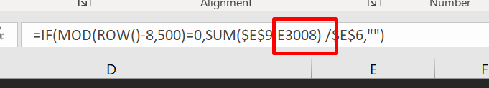
Always trying to have the same value as current column on that red value marked.
      - Add a checkpoint at the end: If after removing the “zeros”, there´s no checkpoint on the last tab that was left, add a checkpoint there.
        - Copy the formula from the Checkpoint (in the end) and edit it to match the current selection, removing the trail ‘ ,””) and the front IF(MOD…).
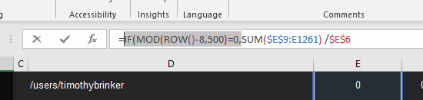
    - Adjust the note that´s referring to the HomePage, accordingly:
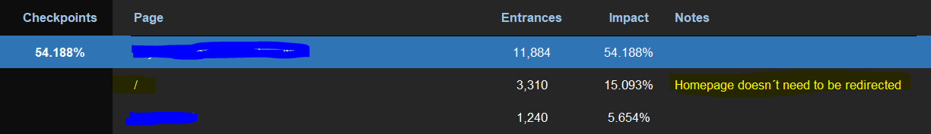
Tengo que llevar el 100% al final, para esto, bajo con CTRL + arrow DOWN hasta el checkpoint de 100%, selecciono la celda entera, copio todo y subo de nuevo hasta la ultima pagina indexada, pego allí en el checkpoint columna, y luego elimino de la formula:
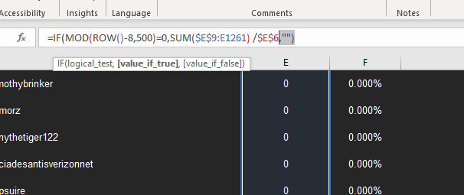

Elimino lo que esta marcado, quedándome:
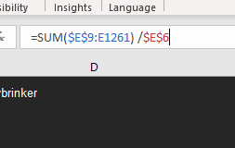
And it will become blue by itself
    - Save
Del archive URLs to 301, borro el “home”:
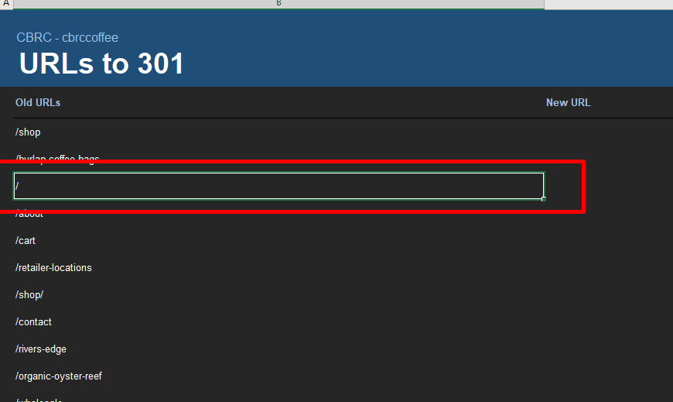

Si tengo mas de 5 mil y no anda, agarrar la celda E9, calcular E9 * 0.95, y bajar esa cantidad de columnas, hasta ahí va a estar el 95%, entonces de esa columna para arriba, copiar y pegar en el URLs to 301.

  - Obtain the total URLs to Redirect and plan the mapping process
Keep in mind our Goal is to always cover +95% of current organic traffic. To identify that:
    - Select the first checkpoint, and hit CTRL+down arrow and keep doing so until you reach a checkpoint that has +95% of the traffic (Select all the “Pages” until checkpoint with +95%)
  - Once into that checkpoint (up to 95% checkpoint), select the URLs from there (from the first one till that point) and paste them on the “URLs to 301” tab, from cell D6. Select and copy URLs until checkpoint 95% does not matter how much are them.
    - Paste on URLs to 301 tab, on old URLs column, the “Pages” url values. (Delete the “/” home one)

Two paths possible from here
  - We don´t have an implementation URL: We consider the Migration File finished and we jump to the next step. The URL check will be done at a later phase when we have an implementation URL.
  - We got an implementation URL: Proceed to check the URLs. This step is in order to avoid sending the customer URLs that won´t change. There´s (normally minimum) cases where the old and the new URL components are exactly the same (lower and upper cases, etc etc). La busco en commerce -> hosting -> domains
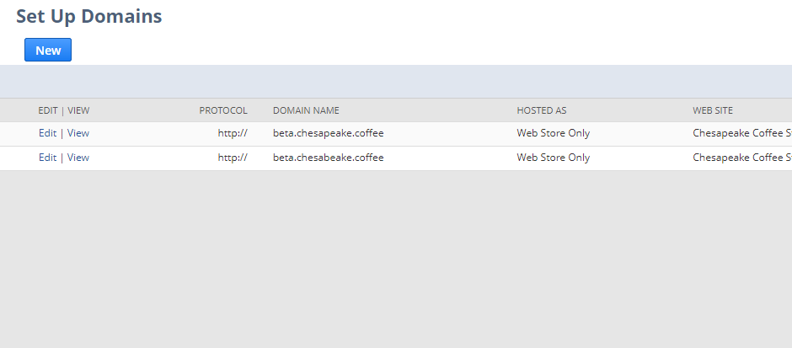
En este caso, beta.chesapeake.coffee es la URL de implementación.
    - Checking the URLs: Go to your Google Drive´s account into the website´s folder and open the “projectname Initial-Pre Redirect Checker” and do the following:
      - Paste the URLs from the “URLs to redirect” tab from the Excel file (Use PASTE SPECIAL, VALUES ONLY)
      - Replace the domain on cell A2, with the implementation URL.
        - IMPORTANT: The domain must NOT include a trial slash.
        - It must include http or https depending the configuration of the domain
      - Once done, there´s going to be an automatic concatenation which will create absolute URLs (protocol+domain+relative url).
      - Go to “Status Checker” on the menu and press run
        - The first time it´ll ask for Authorization, hit continue and select your Oracle account associated to Google
        - Sometimes the HTTPS protocol might fail and you´ll have to hit “Advanced” + “Go to HTTPS Status (unsafe)”
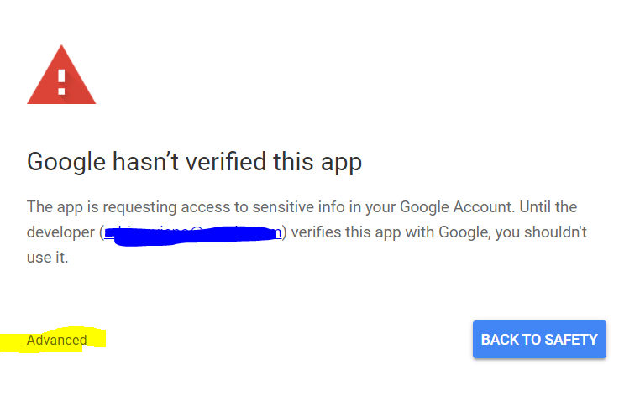
        - Authorize and finally go back to Status Checker and Run again.
      - Once the script runs, it´ll return the HTTP status of the URLs you´re testing and give you a status (see column “Destination Status”)
      - The status code will let you know which ones needs mapping after the migration, meaning, after the website is migrated, a Google Crawl would receive the status codes you´re finding there (considering there´s no redirects yet).
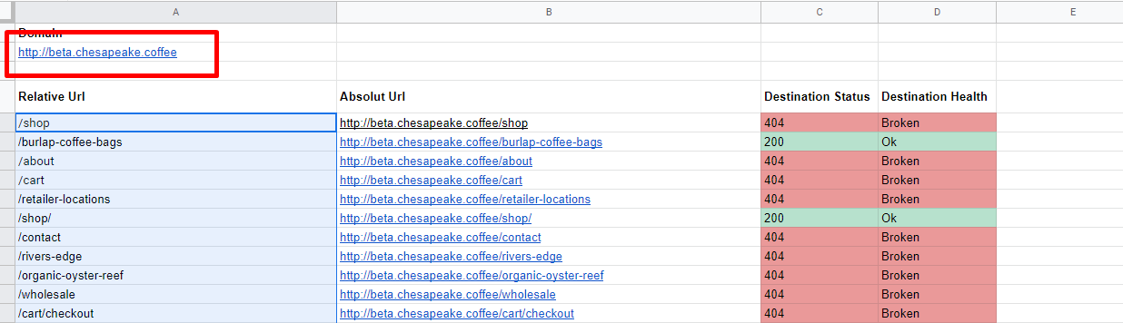
Es el staging domain, nos vamos a fijar si existen en este nuevo staging domain por eso esta prueba.

Then I copy the three columns until Destination Status:
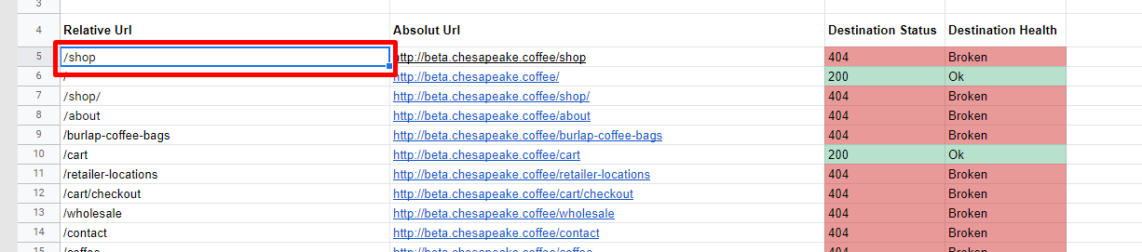
Y las pego en el archivo URLs to 301 (“URLs to 301” tab), en la parte de Old URL con la que se corresponde:
Copio todo en el Excel de Google hasta destination status, y lo reemplazo en URLs to 301, en la tab de old urls y piso new urls y las siguientes columnas.
Then, I press:
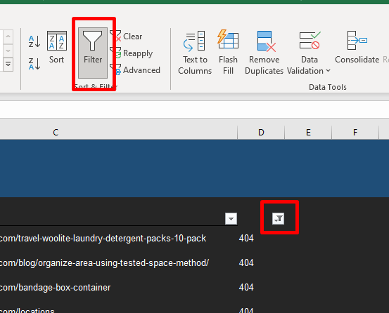
Selecciono el número de fila, y agarro todo.
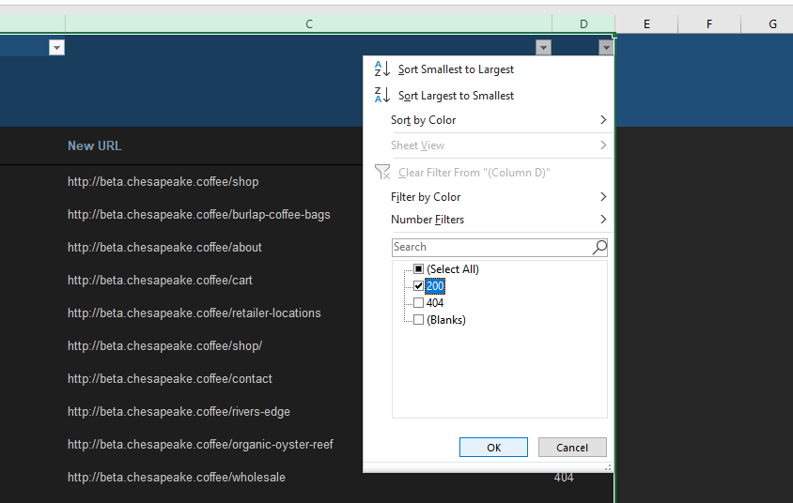
Elimino las 200, Solo dejo las 404, en old url y las voy a mapear dependiendo:
/user/login?destination=cart/checkout esta va a home

        - 404/Broken:
          - The vast majority, or all the urls will return this code. This means the URL needs URL mapping as it won´t work in the new site.
          - As we´re testing the old urls into the new site, its normal that those URLs returns 404 – but is not okay after the golive. That´s what we´re preventing by having Redirects in place.
          - These are the URLs we´ll put into the customer´s URL to 301 file, replacing the old list.
        - 200/ok:
          - Means the URL exists and will work on the new site
          - No redirects are needed in this case, so URLs returning a 200 in this test, should not be included for mapping
            - There´s a chance that this URLs still need a redirect IE: checkout URLs which were indexable in the old site but aren´t indexable in SC so should be mapped to (IE) the home page. Always do a manual test
            - Eliminate them, we should not include them in the URLs to 301 file.
        - 301/loop:
          - Means there´s a redirect to “itself”. The redirect points to the same URL and so there´s a redirects loop
          - These URLs must be included into the URLs to 301 file.
          - It can be the case that an URL looks like a product one, for example: /clearance-overstock/kit-lp-9732-102-003 results in a 301 loop because /kit-lp-9732-102-003 was a legitimate page on the site. In this case, it works to set a redirect in NS to the correct product page. So /clearance-overstock/kit-lp-9732-102-003 needs to be redirected to /kit-lp-9732-102-003. We should go ahead and place these completed redirects in the 301 redirect file for the client to avoid any issues.
          - 301 Loop URLs like /belt-non-oem-m401182p-generic-laundry-parts/?SID=5c0m305inmg9m3akibkj50natq having query parameters should be redirected to the portion prior to the query, so it would redirect to /belt-non-oem-m401182p-generic-laundry-parts.
        - 500 (range of 5XX):
          - Server errors
          - Likely includable into the URLs to 301 file
Note: its always ideal to do a manual verification of, at least, some URLs to make sure the status checks are representing the reality. IE: there´s a chance that a URL returns a 200 but is actually broken (which should be 404) but returns 200 because of a technical error.
      - Clean the “Old URLs” on the URLs to 301 file and replace them with the new ones. On the new URL tab put the mapping, and leave the mapped on the Old URL, for example: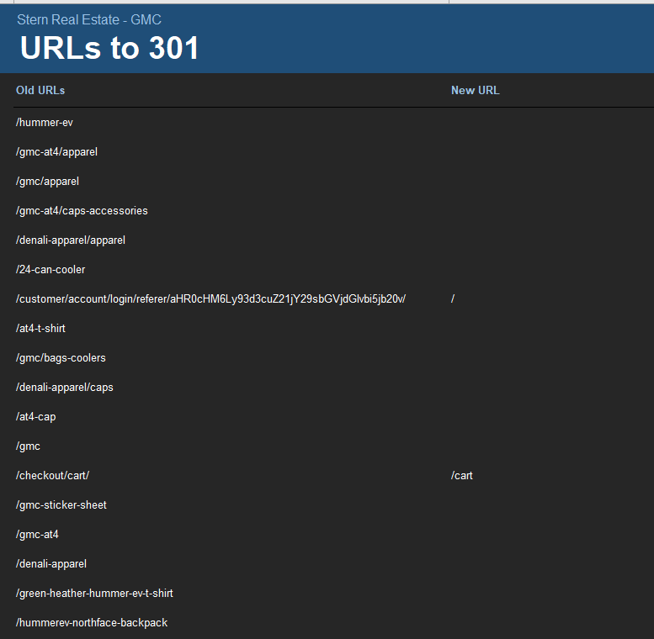
        - In order to sort properly and clean the list, apply a filter to all the columns
        - In the URL column, filter with the following common URLs to identify quickly URLs that needs mapping to the homepage:
          - Checkout
          - Login or Logon, Log in or Log on
          - Register
          - Password
          - Sign in o Sign on, Signin o Signon
          - Account
          - Profile
          - Order
          - Purchase
          - Confirmation
          - Sale
          - Transaction
          - Invoice
          - Opc
          - Review
          - Payment
          - Shipping (or variations)
          - s.nl
          - Home
          - Index
          - Default
          - /~? (Whatever it has “?” after the slash /) (si empieza así, no tiene algo antes)
      - The following URLs should be mapped to “/cart” alone:
        - Basket
        - Examples that contain the word “cart” or /cart/ something
      - Eliminate all other URLs but keep the abovementioned (or highly similar ones) to be redirected (likely to the home page) and add the mapping yourself (in the “New URL”).
    - Last step: Go to the “GA Traffic Analysis” tab, select A1, go to Review/Protect/Protect Sheet, add a password (please use 123456) and hit save. Do not modify nor save again after this point.
- Preparing the Migration Email

Note for the Hispanics: dates and numbers must be in US format

- New email in your Email Software (IE: Outlook)
  - To: CPM or FC+PM,
  - Subject: “(Project’s Name) – URLs to 301 Analysis”
  - Attach Migration Analysis file (URLs to 301 – projectname.xlsx)
  - Body: copy/paste the email template from this link
- Modify the Body based on the analysis:

Introduction:
Start with: “Hi All,”.
Then, modify the CPM name accordingly. Modify the “Attached is the file containing the migration analysis for XXX” (Website/project, not customer name) – it sounds simplistic but it shows you´re doing the analysis for the right website and leaves a chance for CPM, customer, or anyone in copy to have a say.

“XXX Analysis”:

- Modify “XXX Analysis” with the abbreviated name of the project
- Modify “Timeframe” based on what was utilized for the analysis
    - Based on six month timeframe from Google Analytics Organic Data
    - Based on a year timeframe from Google Analytics Organic Data to consider seasonality
  - Modify Domain: IE “Domain: https://www.example.com” (it must contain the protocol and subdomain or root domain).
  - Modify the “Done” date
  - Modify the “Expiration” date (which is a calculation of 6 months from the “done” date)
  - Add needed considerations for GoLive, in example:
      - At the moment of going live http://example.com/ and https://www.example.com/ (secure and primary) will need to be hosted in NetSuite in order to have a successful migration.
      - As they currently have a working secure root domain that redirects to www, at the moment of going live https://example.com/ and https://www.example.com/ will need to be hosted as secure in NetSuite in order to have a successful migration.
      - As they are currently live on a secure root domain, at the moment of going live https://example.com/ and https://www.example.com/ will need to be hosted as secure in NetSuite in order to have a successful migration.
      - Customer is currently choosing whether to migrate only the https://shop.example.com/ or migrate/merge both https://example.com/ and https://shop.example.com/ into NetSuite.
Depending on that, we will update which domains need and how to be hosted at the moment of going live in NetSuite.
      - As they are planning to merge multiple domains into one, at the moment of going live these are the domains to be hosted in NetSuite with this exact configuration:
        - https://www.example.com/ (secure and primary domain)
        - https://example.com/ (root and secure)
        - https://sample.com/ (root and secure)
        - http://www.sample.com/ (non-secure)
Example:
CBRC Analysis:
Based on six month timeframe from Google Analytics organic data.
- Domain: https://www.cbrccoffe.com/
- Done: 04/17/2022 (month / date / year)
- Expiration: 10/11/2022

Key Findings:

Note: the information to modify the following sections is within the Analysis file.

- Modify number of indexed URLs in Google “The site has a total of XXX URLs indexed by Google”. I can check this out on the Google screen shot that I have taken before: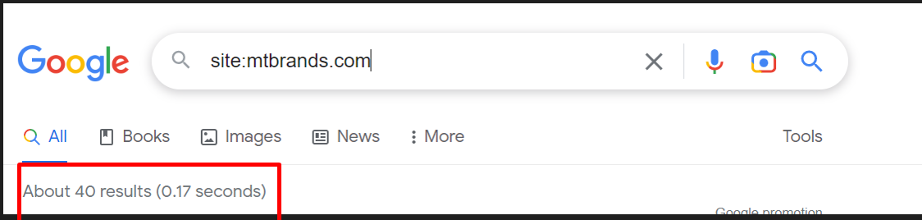

- Modify the URLs tracked in Google and the % of traffic being covered.
“In “GA Traffic Analysis” tab are the first X,XXX URLs tracked by GA, covering XX.XX% of the total organic traffic”.
I can get this data from our spreadsheet, on first tab we select all entrances (after the ones with 0 impact and 0 entrances have been deleted) and we count the quantity, it can happen that it can get more than 95%, it’s okay (On next step, we will count only up to the 95%)
Contar en el excel desde la primera, hasta la ultima, luego de haber eliminado las que tienen entradas 0 e impacto 0, y de ahí obtengo el porcentaje asociado a la ultima, que va a ir en el mail. Puede ser 100
Note: depending on how you decide to send the URLs to the customer (IE: if you´re sending a bigger list than the 95%), the message can be adapted to explain that.

Several cases for this:
- I have more than 5000 URLs in Google Analytics screen:
En Google analytics tenía mas de 5000, pero miro el archivo URLs to 301. Voy al archivo URLs to 301, a la tab de GA Traffic Analysis, aprieto en el resultado de page, control + shift + abajo:
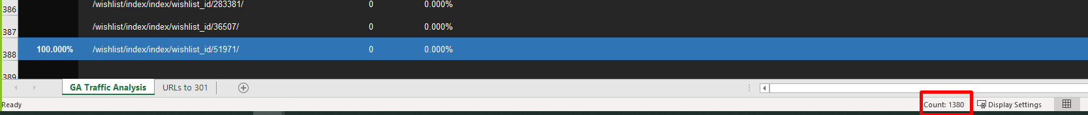
Marco el que dice Count: 1380 resultados, que contienen el 100% del traffic orgánico, en el checkpoint lo marca. Como había muchas más de 5000 en Google analytics, y las habíamos sacado de acá, entonces en el mail, en la parte correspondiente pongo: “In “GA Traffic Analysis” tab are the first 5000 URLs tracked by GA, covering 100% of the total organic traffic”.
Luego, en “We took the first X,XXX URLs, covering XX.XX% of the total organic traffic” lo lleno con el count de 1380 (si es mas de 250 entonces cubre el 100%, sino pongo el porcentaje del checkpoint).
- En cambio, en otro proyecto tengo 29 urls indexadas, y en Google había solo esa cantidad
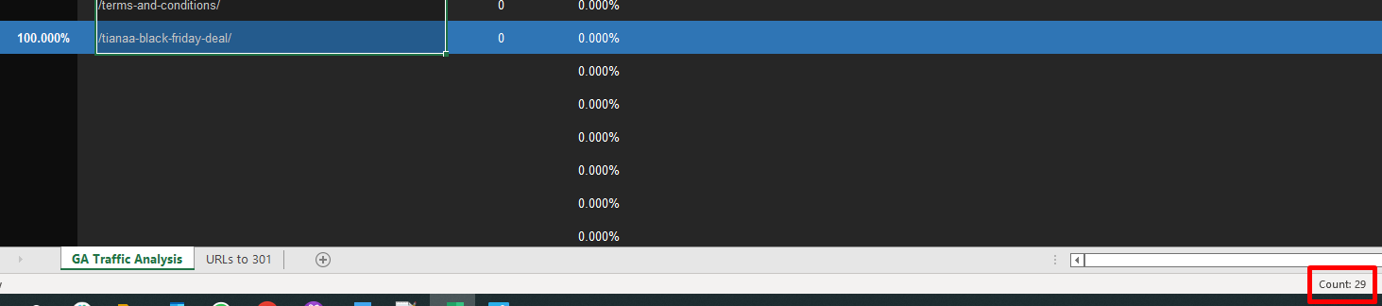
Entonces en el mail pongo: “In “GA Traffic Analysis” tab are the 29 URLs tracked by GA, covering 100% of the total organic traffic”
- On the “URLs to be mapped” section, you must change:
    - “We took the first X,XXX URLs, covering XX.XX% of the total organic traffic”.

Para este step, algunos casos:
- Tengo mas de 250 redirects:
Voy hasta el primer checkpoint que tenga con 250 redirects.
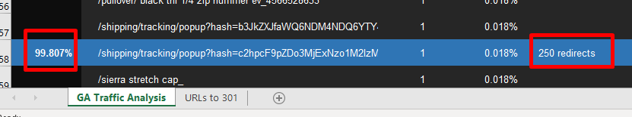
Y de esto, obtenemos que el count es 250, copio el count sin contar la redirección a home (en realidad, ya fue eliminada) y es por eso que es menor al numero anterior marcado en el bullet superior.
Por eso en vez de 250, usamos 249, y usamos el valor del checkpoint para completar, en este caso, queda:
“We took the first 249 URLs, covering 99.81% of the total organic traffic”.

- Tengo menos de 250 redirects:

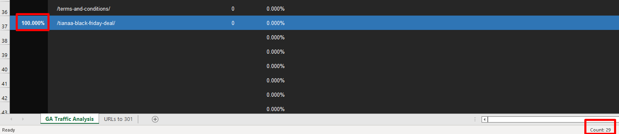
En este caso entonces, descuento el home y tengo que poner 29, y veo que el checkpoint cubre el 100%, por lo tanto:
“We took the 28 URLs, covering 100% of the total organic traffic”.

    - Add the following bulletpoints (add only the ones which apply, delete the rest):
      - All URLs that are from the cart, login, registry, checkout or accounts were mapped to the homepage, because these URLs are not indexable
      - All URLs that remain the same on the new site were removed from mapping list
      - Incompatible urls such as certain types of queries were discarded
      - Some urls are already properly mapped for customer to use as an example

Action Items:
Typically no modifications. If customer doesn´t have to map URLs for some reason, we modify with “No further actions are required”.
Final example:
You can check this example on email.
Key Findings:
- The site has a total of 147 URLs indexed by google
- In “GA Traffic Analysis” tab are all 1253 URLs tracked by GA, covering 100% of the total organic traffic or
- URLs to be mapped:
  - In the “URLs to 301” file you will find the URLs that need to be mapped for the new site
  - We took the first 249 URLs, covering 100.00% of the total organic traffic
  - All URLs that are from the cart, login, registry, checkout or accounts were mapped to the homepage, because these URLs are not indexable
  - All URLs that remain the same on the new site were removed from mapping list
Action Items:
- Map URLs to the equivalent new site pages once the URL structure defined and content is loaded (Customer Task)
  - Note: You need to take the URL segment after the .com and paste it on the “New URL” column of the sheet, e.g.: /example-category/example-subcategory
- Creation of missing equivalent landing pages on the new site (Customer Task)
- Check the redirects mapping status when it’s complete (DX Task)
- If the mapping is correct proceed with the creation of the redirects CSV file to be imported during the go-live (DX Task)

- Updating Task
Once the Migration Analysis was sent, we go back to the Task to update the task record as follows:
  - Assigned to: CPM
  - Next Step: Customer to execute on recommendations & Deliver Mapped 301 Redirects file
  - Next Due Date: 10 days before going live.
You can check this on the task, on prof services tab:
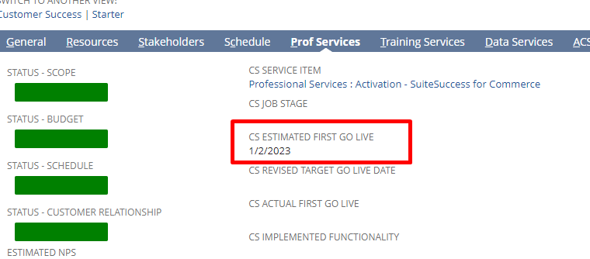

Customer doesn´t have Google Analytics:

Step 1: Initial Assessment
Create your folders:
In Local, you should have a structure like: Work/Customers/PS and Work/Customers/ACS. Create a folder into it with THE WEBSITE´S NAME (to avoid future confusions). IE: /Work/Customers/PS/MyCustomerSite
The following files must be added to the folder (there´s going to be guidance as to how to get those files as the project progresses):
- Google Search Console verification file (which can be obtained into Google Search Console´s account) (This is something we get during post go live process, this file changes on regular basis so having static file won’t work). (Do on Post Go-Live)
  - Go to Google Search Console (https://search.google.com/search-console/)
  - Go to Properties dropdown (top left) and select Add Property
  - Inside the popup, in the URL Prefix field, paste the live domain i.e.: https://www.example.com/.
  - Click on Continue.
  - Following the on screen prompts within the console, you will see:
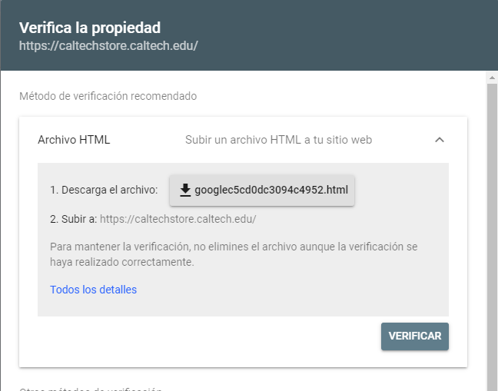
  - Press Verify
    - If you are unable to verify site ownership for some reason, ask a current owner to grant you access to the property in Search Console.
- “Robots.txt” file. This can be utilized as a backup during post golive checkpoint
- “GSR_X.txt” this file contains the export from Google Search Results Pages and there´s going to be many of them depending on the size of the website. (Used later for 301 file)
  - Go to an incognito Window in Google Chrome
  - Enable the OScraper extension, modifying the options to get 100 results and “USA” as region.
  - Press on go
  - On the search bar (NOT in the browser bar) you must type the “site:” corresponding to the site you were checking before.
  - Once you get the Search Results:
    - Click on OScraper Extension
    - Click on Save Current Page
    - On the save window, select the GSR_1 file and start replacing accordingly (GSR_1 for the first page, GSR_2 for the second and so on)
    - Repeat the process for as many pages as you can. Google will limit you to the 10-20% of the total URLs anyways – which are coincidentally the top 10-20% of the site according to google itself.
- “URLs to 301 – projectname.xlsx” this is the migration analysis file which we´ll explain below. This is a template that you´ll be working on afterwards
- “projectname Redirects.csv” the file with the final redirects to be imported to NetSuite during the go live.

In Google Drive (drive.google.com), you structure must look like: MyDrive/Analysis/PS, and into it you should create a folder per website (not per customer, but website).
The files you´ll host into that folder are allocated into MyDrive/Templates (these are ORIGINAL files you should never edit).
Select the files: “Template Initial-Pre Redirect Checker”, “Template Post Redirect Checker” and “Template Redirects”.
Make a copy of those 3 into your customer´s drive folder, and edit the names to replace “template” with the customer´s name. IE: “MyCustomer Initial-Pre Redirect Checker” and so on

Step 2: Migration Analysis
- First we start by doing an overall quick analysis of the migrating (current) website. If we find something abnormal or information that wasn´t provided (be sure this will be the case, pay attention), ask the consultant or customer for clarifications.
With Abnormal we might be speaking about:
  - Find a valid subdomain that we weren´t told about. IE: sprigusa.com is the customer´s website, but during the analysis we found shop.sprigusa.com which we weren´t notified about.
In this case, we need to ask the customer what site are they migrating – or if they are planning to unify both into a single site/domain.
  - Check for a Blog, and see if its hosted either separately or on a /blog structure. If the blog is separate (different domain or exclusive subdomain) we recommend to keep it without migration. If its /blog or similar, there´s dozens of possibilities including the site being completely different (even tho hosted within the same domain) and have its own tracking tools (which means we need different accesses to analyze the traffic that goes to it).
We ARE in charge of the migration of a /blog as well so make sure to pay attention to every detail.
  - Those were JUST EXAMPLES and you must use your critical SEO eye to identify others.
- Check how many Indexed URLs the site has in Google
  - Open new Incognito window (this is: close all incognito you have, and open from scratch. Pay attention to “window” vs “tab”).
  - On the search bar, type “site:” followed by the (sub)domain you need to check
    - Do not use “http://” nor “https://”
    - Do not use trialing slash (IE: www.example.com/ vs www.example.com this second one is the right one to use)
    - Make sure to be checking the right (sub)domain. www and root are “one thing” so if you´re checking www, check the root.
    - Valid examples:
      - site:www.example.com
      - site:example.com
      - site:shop.example.com

- Extract URLs to be migrated:
  - Go to an incognito window in Google Chrome
  - Enable the OScraper extension, modifying the options to get 100 results and “USA” as region.
  - Press go
  - On the search bar (NOT in the browser bar) you must type the “site:” corresponding to the site you were checking before.
  - Once you get the Search Results,
    - Click on OScraper extension
    - Click on Save Current Page
    - On the save window, select the GSR_1 file and start replacing accordingly (GSR_1 for the first page, GSR_2 for the second and so on)
    - If it does not save all the pages, scroll down on the google search and select again on save current page so it saves from the point you are watching, then you merge both files.
    - Repeat the process for as many pages as you can. Google will limit you to the 10-20% of the total URLs anyways – which are coincidentally the top 10-20% of the site according to google itself.
- Open the “URLs to 301 – projectname.xlsx”
  - The file has templated data loaded into it which you´ll have to clean/replace with your project´s information
  - Change customer´s name and project on cell B2 (type it, don´t copy paste)
  - Change the domain on D6. It MUST MATCH with the domain you´re running the traffic analysis on.
    - Note: it mustn´t be hyperlink so make sure you´re removing the link if that happens automatically.
    - Mustn´t contain http nor https
  - Delete the list of Old and New URLs
SAVE the file now, after completing the above. Open the “URLs to 301 – projectname.xlsx” file

- Complete the migration analysis:
  - Open the first GSR file, copy and go to the Excel file
  - Once in excel, go to “URLs to 301” and paste the URLs in to the “Old URLs” column
  - Repeat the process for all the GSR files, pasting the URLs below
  - Last, use a Search and Replace function to remove the domain. IE:
    - Search: www.example.com/
    - Replace: /
  - Note, if the “/” appears (representing the home) then remove that row as it won´t require a 301.
  - Save the file
  - First tab GA Traffic Analysis is kept empty as the following:
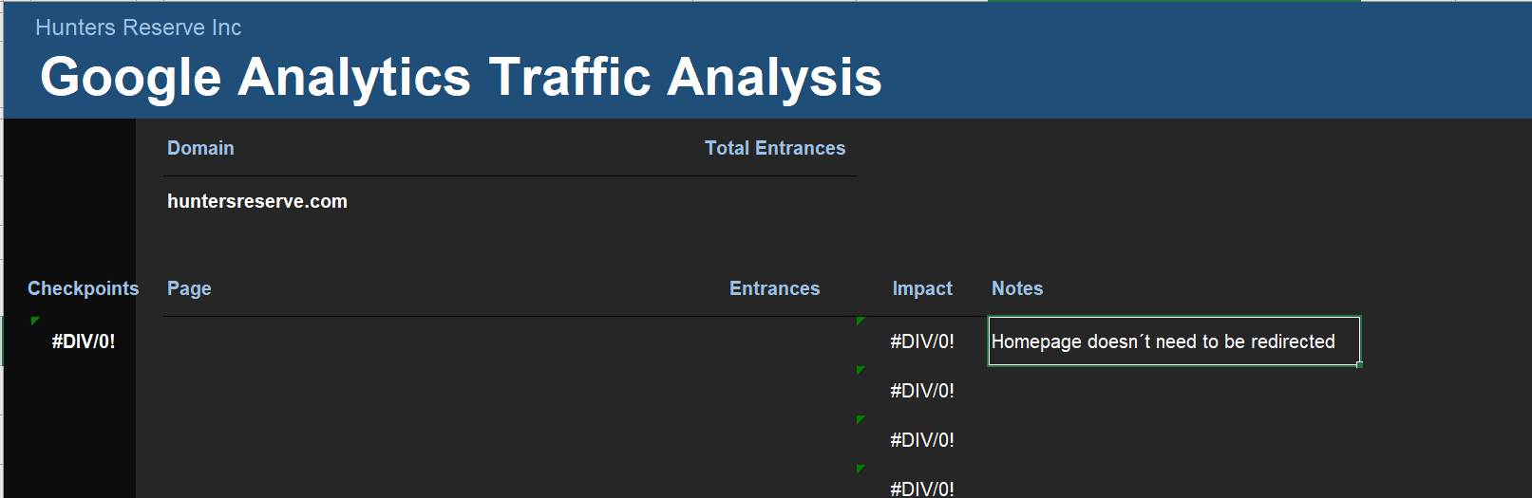
- Process URLs to map

Note: Different to a Traffic Analysis with GA, we consider 100% of the URLs that came up from this method.

Two paths possible from here
  - We don´t have an implementation URL: We consider the Migration File finished and we jump to the next step. The URL check will be done at a later phase when we have an implementation URL.
  - We got an implementation URL: Proceed to check the URLs. This step is in order to avoid sending the customer URLs that won´t change. There´s (normally minimum) cases where the old and the new URL components are exactly the same (lower and upper cases, etc etc).
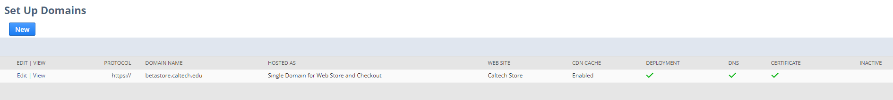
In this case implementation URL is betastore.caltech.edu
    - Checking the URLs: Go to your Google Drive´s account into the website´s folder and open the “projectname Initial-Pre Redirect Checker” and do the following:
      - Paste the URLs from the “URLs to redirect” tab from the Excel file (Use PASTE SPECIAL, VALUES ONLY) (Copy the old URL values on second tab from Excel File URLs to 301)
      - Replace the domain on cell A2, with the implementation URL.
        - IMPORTANT: The domain must NOT include a trial slash.
        - It must include http or https depending the configuration of the domain
      - Once done, there´s going to be an automatic concatenation which will create absolute URLs (protocol+domain+relative url).
      - Go to “Status Checker” on the menu and press run
        - The first time it´ll ask for Authorization, hit continue and select your Oracle account associated to Google
        - Sometimes the HTTPS protocol might fail and you´ll have to hit “Advanced” + “Go to HTTPS Status (unsafe)”

        - Authorize and finally go back to Status Checker and Run again.
      - Once the script runs, it´ll return the HTTP status of the URLs you´re testing and give you a status (see column “Destination Status”)
      - The status code will let you know which ones needs mapping after the migration, meaning, after the website is migrated, a Google Crawl would receive the status codes you´re finding there (considering there´s no redirects yet).
        - 404/Broken:
          - The vast majority, or all the urls will return this code. This means the URL needs URL mapping as it won´t work in the new site.
          - As we´re testing the old urls into the new site, its normal that those URLs returns 404 – but is not okay after the golive .That´s what we´re preventing by having Redirects in place.
          - These are the URLs we´ll put into the customer´s URL to 301 file, replacing the old list.
        - 200/ok:
          - Means the URL exists and will work on the new site
          - No redirects are needed in this case, so URLs returning a 200 in this test, should not be included for mapping
            - There´s a chance that this URLs still need a redirect IE: checkout URLs which were indexable in the old site but aren´t indexable in SC so should be mapped to (IE) the home page. Always do a manual test
        - 301/loop:
          - Means there´s a redirect to “itself”. The redirect points to the same URL and so there´s a redirects loop
          - These URLs must be included into the URLs to 301 file.
        - 500 (range of 5XX):
          - Server errors
          - Likely includable into the URLs to 301 file
Note: its always ideal to do a manual verification of, at least, some URLs to make sure the status checks are representing the reality. IE: there´s a chance that a URL returns a 200 but is actually broken (which should be 404) but returns 200 because of a technical error.
      - Clean the “Old URLs” on the URLs to 301 file and replace them with the new ones.
        - In order to sort properly and clean the list, apply a filter to all the columns, on the statuses you should only keep the “200” (Eliminate the 200 and keep 400)
        - In the URL column, filter with the following common URLs to identify quickly URLs that needs mapping to “/” (home even) though they are a 200:
          - /
          - Checkout
          - Login o Logon, Log in o Log on
          - Register
          - Password
          - Sign in o Sign on, Signin o Signon
          - Account
          - Profile
          - Order
          - Purchase
          - Confirmation
          - Sale
          - Transaction
          - Invoice
          - Opc
          - Review
          - Payment
          - Shipping (or variations)
      - Eliminate all other URLs, but keep the above mentioned (or highly similar ones) to be redirected (likely to the home page) and add the mapping yourself (in the “New URL”).
Last step: Save the file and don´t edit again once finished.

- Preparing the Migration Email

Note for the Hispanics: dates and numbers must be in US format

- New email in your Email Software (IE: Outlook)
  - To: CPM or FC+PM
  - Subject: “(Project’s Name) – URLs to 301 Analysis”
  - Attach Migration Analysis file (URLs to 301 – projectname.xlsx)
  - Body: copy/paste the email template from this link
- Modify the Body based on the analysis:

Introduction:

Modify the CPM name accordingly. Modify the “Attached is the file containing the migration analysis for XXX” (Website/project, not customer name) – it sounds simplistic but it shows you´re doing the analysis for the right website and leaves a chance for CPM, customer, or anyone in copy to have a say.

Analysis:

- Modify “XXX Analysis” with the abbreviated name of the project
- Modify “Based on the indexed urls in Google search results”, it’s the only one that applies and the only message you should utilize.
- Modify Domain: IE “Domain: https://www.example.com” (it must contain the protocol and subdomain or root domain).
  - Modify the “Done” date
  - Modify the “Expiration” date (which is a calculation of 6 months from the “done” date)
  - Add needed considerations for GoLive, in example:
      - At the moment of going live http://example.com/ and https://www.example.com/ (secure and primary) will need to be hosted in NetSuite in order to have a successful migration.
      - As they currently have a working secure root domain that redirects to www, at the moment of going live https://example.com/ and https://www.example.com/ will need to be hosted as secure in NetSuite in order to have a successful migration.
      - As they are currently live on a secure root domain, at the moment of going live https://example.com/ and https://www.example.com/ will need to be hosted as secure in NetSuite in order to have a successful migration.
      - Customer is currently choosing whether to migrate only the https://shop.example.com/ or migrate/merge both https://example.com/ and https://shop.example.com/ into NetSuite.
Depending on that, we will update which domains need and how to be hosted at the moment of going live in NetSuite.
      - As they are planning to merge multiple domains into one, at the moment of going live these are the domains to be hosted in NetSuite with this exact configuration:
        - https://www.example.com/ (secure and primary domain)
        - https://example.com/ (root and secure)
        - https://sample.com/ (root and secure)
        - http://www.sample.com/ (non-secure)
Key Findings:

- Modify number of indexed URLs in Google “The site has a total of XXX URLs indexed by Google”
- “Customer didn’t have a Google Analytics account” must stay intact. There´s variations like “customer´s account wasn´t properly working on the site” or “customer couldn´t provide access to its account”
- On the “URLs to be mapped” section, you must change:
    - “We took the first X,XXX URLs from Google Search Results”.
    - Add the following bulletpoints:
      - All URLs that are from the cart, login, registry, checkout or accounts were mapped to the homepage, because these URLs are not indexable
      - All URLs that remain the same on the new site were removed from mapping list
      - Incompatible urls such as certain types of queries were discarded
      - Some urls are already properly mapped for customer to use as an example

Action Items:

Typically no modifications. If customer doesn´t have to map URLs for some reason, we modify with “No further actions are required”.

- Updating Task
Once the Migration Analysis was sent, we go back to the Task to update the task record as follows:
  - Assigned to: CPM
  - Next Step: Customer to execute on recommendations & Deliver Mapped 301 Redirects file
  - Next Due Date: 10 days before going live.

Closed Site (Full Password Protected):

At the beginning of a Password Protected Site project we´ll send a list of actions for the CPM to complete and will be the guide for future checks.
For this we use the “DX Action List” template, and modify the following:
Note for the Hispanics: dates and numbers must be in US format

- New email in your Email Software (IE: Outlook)
  - To: CPM or FC+PM
  - Subject: “[Project’s Name] – DX Action List”
  - Body: copy/paste the DX Action List

DX Action List Template:
Hi CPM,

Here’s the DX action list for Customer

- Confirm which will be the domain where the site will live (CPM / Customer) – Done
  - https://shop.fayette.com
- Provide implementation URL (CPM) – Done
  - https://staging.fayette.com/
- Create and/or provide access to a GA property for the new site (Customer) – Done
  - ID: UA-11548704-2
- Create and/or provide access to a GTM container for the new site (Customer) – Pending
  - Access requested.
- Grant backend access for DX (CPM) – Done
- Configure GA and GTM (DX) – Pending
  - Depends on GTM access
- Modify robots.txt to Disallow: / (DX) – Done
- Fill up support case on behalf of the customer requesting to “Enable Switch 17” to disable the SEO Engine only for this specific website record and not whole account. (CPM) – Pending
  - Note: the switch off this SEO Page Generator represent a great performance improvement for B2B password protected customers and the switch off will automatically add an specific meta tag to prevent the indexation of the site.

Site has pending items to be cleared.

Thank you

Introduction:

Modify the CPM name accordingly. Modify the “Attached is the file containing the migration analysis for XXX” (Website/project, not customer name) – it sounds simplistic but it shows you´re doing the analysis for the right website and leaves a chance for CPM, customer, or anyone in copy to have a say.

Actions:

    - Line 1: “Confirm which will be the domain where the site will live” (CPM or FC should confirm this)
      - Status: Done / Pending
Note: If Done, put a sub bulletpoint with the domain that was confirmed.
If not done, we should tag the FC/CPM assigning the action item.
    - Line 2: “Provide Implementation URL” (CPM or FC should confirm this)
      - Status: Done / Pending
Note: If Done, put a sub bulletpoint with the domain that was confirmed.
If not done, we should tag the FC/CPM assigning the action item.

    - Line 3: “Create and/or provide access to a GA property for the new site (Customer)” (CPM or FC should ask for this)
      - Status: Done / Pending
Note: If Done, put a sub bulletpoint with the GA ID confirmed
If not done, mention that the customer has this as a pending action item (FC/CPM must follow up)
Add GA4 to this.
    - Line 4: “Create and/or provide access to a GTM container for the new site (Customer)” (CPM or FC should ask for this)
      - Status: Done / Pending
Note: If Done, put a sub bulletpoint with the GTM ID confirmed
If not done, mention that the customer has this as a pending action item (FC/CPM must follow up)

    - Line 5: “Grant backend access for DX”
      - Status: Done / Pending
Note: If Done, no additional bulletpoints.
If not done, tag the CPM/FC for action

    - Line 6: “Configure GA and GTM ” This is done by DX
      - Status: Done / Pending
Note: If Done, no additional bulletpoints.
If not done, mention the reason why it isn´t done and the dependency (IE: missing X access)

    - Line 7: “Modify robots.txt to Disallow: /” this is done by DX
      - Status: Done / Pending
Note: If Done, no additional bulletpoints.
If not done, mention the reason why it isn´t done and the dependency (IE: missing X access)
      - We must verify there´s a robots.txt disallowing robots from crawling the site, to avoid potential weird indexations
      - Robots.txt must be configured as:
User-agent: *
Disallow: /

How to work with Robots.txt:

Verify if robots.txt is configured at all. For that, visit the implementation-url/robots.txt and see what´s there.
If it says anything different thank “Disallow:” (note it’s a “Disallow:” without the slash, meaning it allows everything) it means the robots.txt is not configured and the default is being shown.

How to configure robots.txt?

- Go to backend account
- Documents / Files / File Cabinet
- Click on Live Hosting Files
  - The project might use another folder instead. Check on the Website Record (Commerce/Websites/Website List, select the website and on the setup tab you´ll see “Default Hosting Root”)
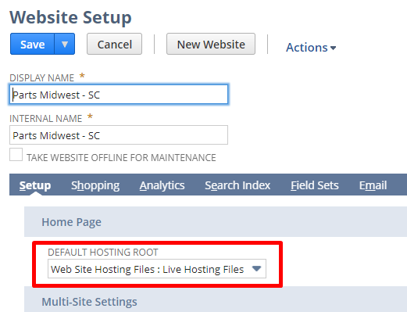
- Go to “Add File” and select the robots.txt you should have previously created in Local
- Note: If the file IS there, edit that one or just replace it

IMPORTANT: What to do if there´s more than one site on the same account? The robots.txt would be shared, and you don´t want all sites to be prevented from crawling, so:

Create a “b2b_robots.txt” file, and create a redirect from the-b2b-site.com/robots.txt to /b2b_robots.txt.

    - Line 8: “Fill up support case on behalf of the customer requesting to “Enable Switch 17” to disable the SEO Engine only for this specific website record and not whole account.” CPM or FC should do.
      - Status: Done / Pending
Note: If Done, no additional bulletpoints.
If not done, mention the reason why it isn´t done and the dependency (IE: missing X access)
      - Note: the switch off this SEO Page Generator represent a great performance improvement for B2B password protected customers and the switch off will automatically add an specific meta tag to prevent the indexation of the site.
      - Please cc us on the support ticket

How to check if Switch 17 is enabled:

On incognito window, go to view source and do a SEO Debugging (?seodebug=T&preview=123123 while 123123 must be always a random/unique number). Go to SEO Engine´s section and check that it did not run.

Closure Email:

At the end of the email, we add the situation of the project:

  - Site has (a) pending item(s) to be cleared.
  - Site doesn’t have pending items to be cleared

Updating Task
Once the DX Action List was sent, we go back to the Task to update the task record as follows:
  - Assigned to: CPM
  - Next Step: Customer/CPM to work on pending items
  - Next Due Date: 10 days before going live.

Tracking Tools config

NOTE: At this point its assumed you got all the accesses correctly, which should have been verified in previous steps.
There´s 3 steps to configure tracking tools.
- Verify and adjust Google Analytics configurations
- GTM Editor bundle configuration & Google API configuration
- Integrating third party services, tracking tools and live chats

Verify and adjust Google Analytics configurations (only for GA3)

Access the GA Account and go to the Property ID.

Browse to Admin Panel (bottom left)

Check if there´s one or more sites on the same property. For that you may:

- Check the names of the views (check if there´s multiple domains mentioned)
- Check Website´s URL on the Admin/View Settings
- On the Behavior/SiteContent/All Pages, apply hostname filter and see if there´s more than one domain tracked
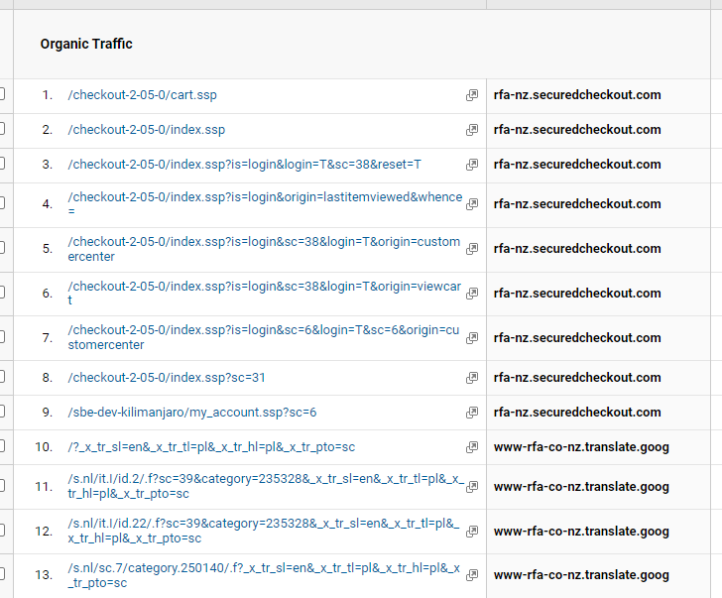
What do we do when there is more than one domain?
Attention: Do not interact with other fields beyond the ones explained below.

At Property Level:
- Property Settings
  - Property Name: We must check the name is appropriate according to the site/project we´re working on. DO NOT modify it if there´s more than one site being tracked
IE: If the name says “NetSuite Test” we should modify it for the project name or customer name
  - Default URL:
    - There´s a selector for http and https, which means: the second field MUST NOT contain the protocol. The second field is for the hostname (domain+subdomain, without trial slash and without protocol)
    - The configuration should be for the “new” site (so likely HTTPS, likely with WWW, etc) and may not necessarily match at 100% with the old domain´s configuration (might be http, might be root domain, etc).
    - If it’s a new site, just make sure to use the proper protocol and (sub)domain
  - Default View: do not modify if multiple sites are being tracked on the same property.
If there´s nothing selected: select the view that makes more sense – ideally one that´s not filtered.
  - Industry category: select the one that makes more sense. This is not mandatory though.
  - Enable Demographis and Interest reports: Yes, if possible
  - Enable User Metric in Reporting: Yes, if possible
  - Save.
- Tracking Info / Referral Exclusion List:
  - Check that the root domain is listed. For new properties/new domains, this is frequently automatic
  - To add a new root domain into it, hit the “+ Add Referral Exclusion” and type the root domain.
  - Add the other following excludable domains: netsuite.com, netsuitestaging.com which are in order to avoid referrals from those sources (frequently utilized for testing purposes)
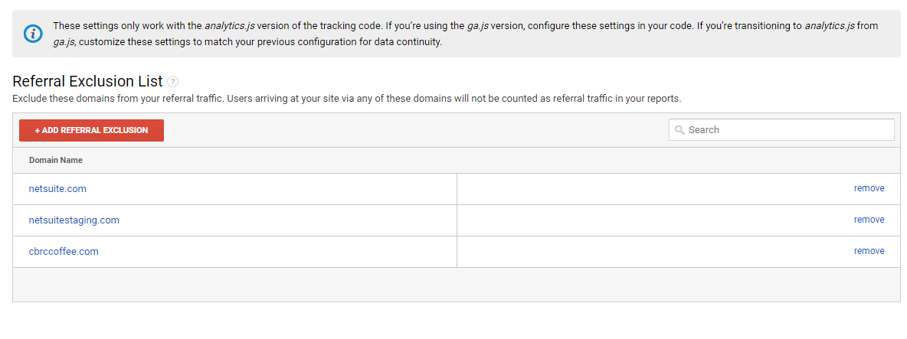
Root domain is without “www.”
At View Level:
- View Settings
  - View Name: Check that the name makes sense for the project at hand. DO NOT modify if its being utilized for more than one site
  - Website´s URL:
    - This is for THE FINAL site, not for the configuration of the old site. Select http or https, then type the host name (sub domain or domain, without protocol nor trial slash)
  - Time Zone country or territory
    - By default Analytics will show US and GMT-08:00. We can keep it this way if we are unsure about customer´s timezone
  - Default Page
    - Migrated site: we don´t modify it at this phase
    - New site: empty
  - Exclude URL query parameters:
    - Migrated site: we don´t modify it at this phase
    - New site: empty
  - Currency Displayed as:
    - By default we´ll see US Dollars. It should be like this in most cases.
    - If we´re the ones creating the view, we should ask the customer if we are unsure (typically we´ll see it in the site)
  - Bot Filtering:
    - Always selected
  - Site Search Tracking:
    - Migrating site: we don´t modify it at this phase
    - New site: enable
      - Query Parameter: “keywords”
    - Strip query parameters out of URL:
      - New site: must NOT be enabled
      - Old site: leave as is, and modify during golive
    - Site Search Categories:
      - Migrating site: don´t modify at this phase
      - New site: must be disabled
- Ecommerce Settings:
  - Enable Ecommerce
  - Enable Enhanced Ecommerce Reporting

- Save

Verify and adjust Google Analytics configurations (only for GA4)

- Get GA4 ID: Ids for GA4 do not have the characters “UA”, you can get the GA4 tag on Google Analytics account:
  - Go to property -> Admin -> Data Streams and select the appropriate stream:
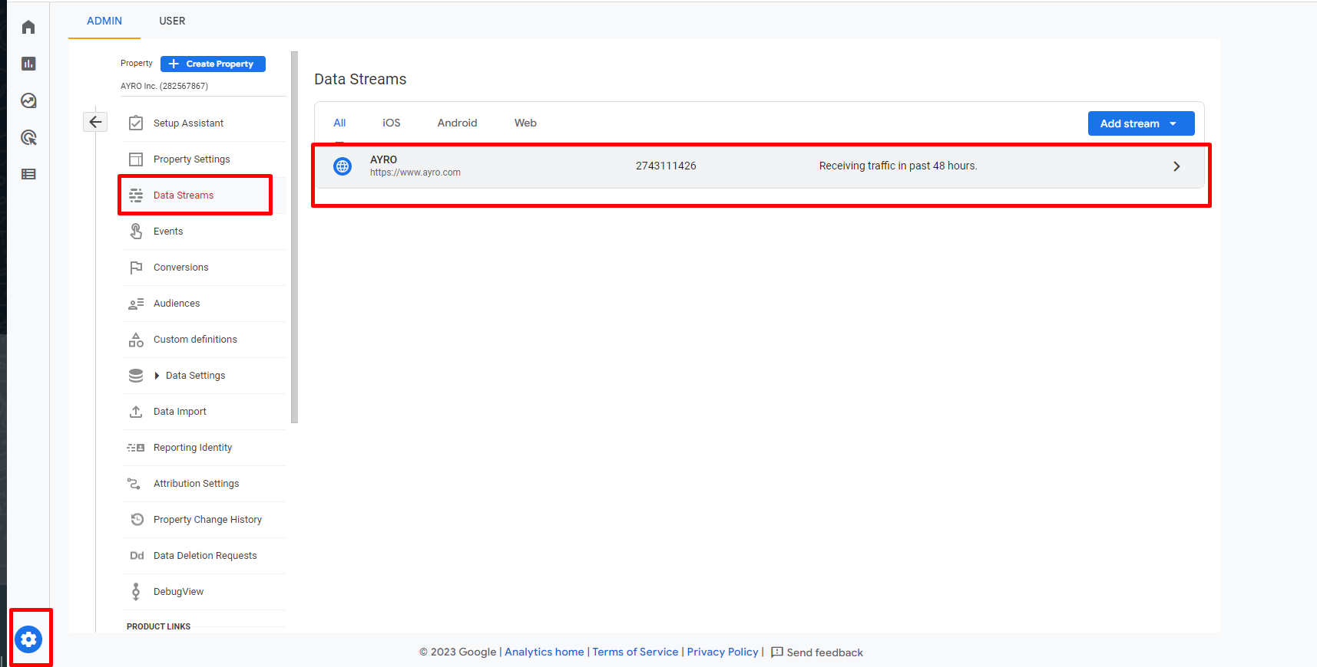
Then, it will open:
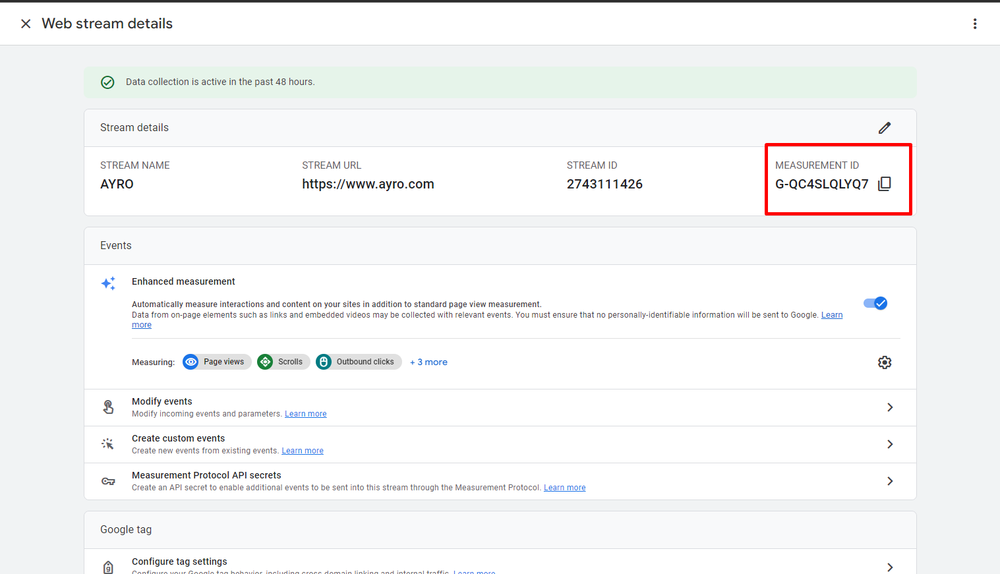
And the measurement ID is the GA4 ID.

If stream url is not set and is empty, we should add their final domain (not the testing):
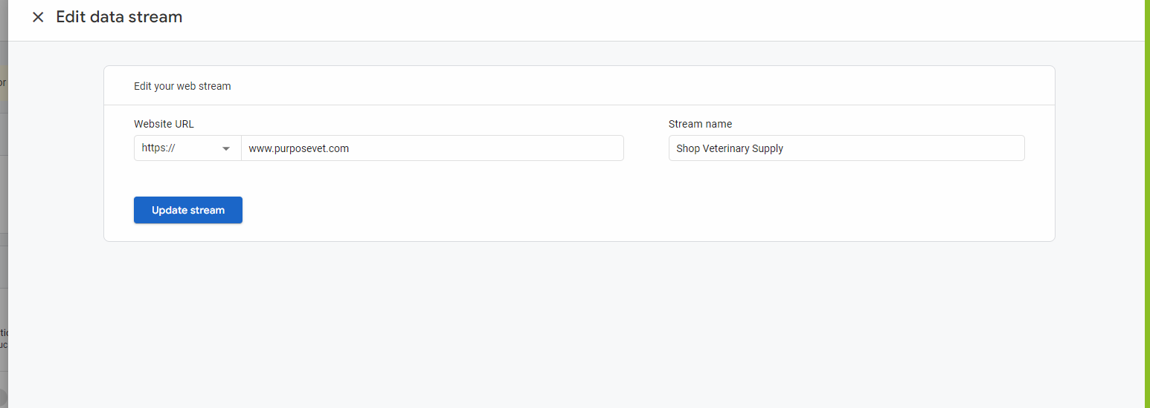

We are going to use later this ID to set it on Google Tag Manager Editor as service for GA4. (Setup -> Suite Commerce Advanced -> Google tag manager editor and we add GA service).

- Tracking Info / Referral Exclusion List:
  - Property -> Data Streams -> Select Web data stream -> Web Data stream -> Configure Tag Settings -> Show All -> List Unwanted referrals in the last screen
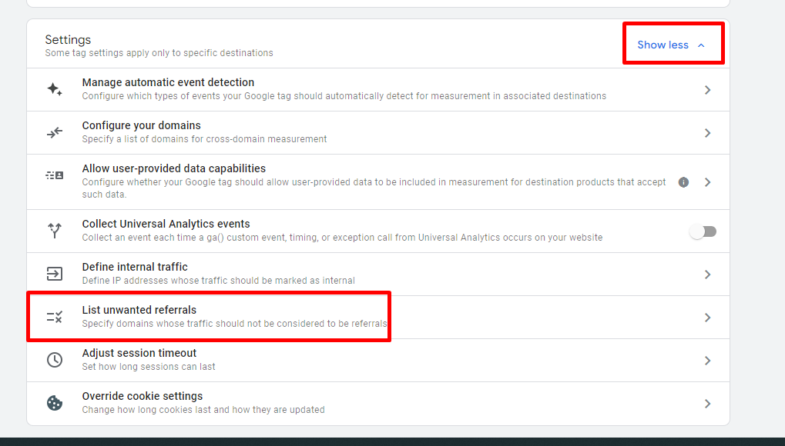
Add with “match type: referral domain contains” the domains:
- netsuitestaging.com
- netsuite.com
- The site domain (www.ayro.com) without www, so it would be -> ayro.com
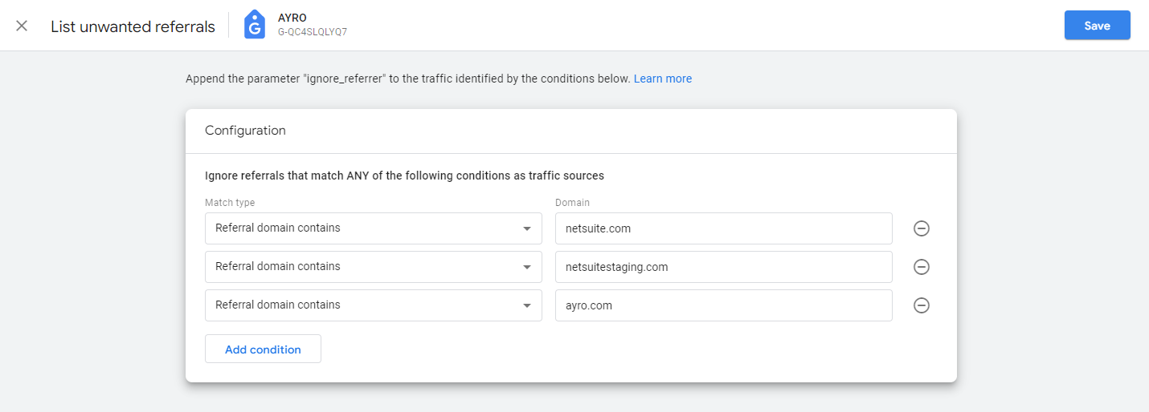

Go to Property -> Property details:
- Property details
  - Property Name: We must check the name is appropriate according to the site/project we´re working on. DO NOT modify it if there´s more than one site being tracked
IE: If the name says “NetSuite Test” we should modify it for the project name or customer name
  - Industry Category: select the one that makes more sense.
  - Currency: fill up

GTM Editor bundle configuration & Google API configuration
How to install:
- Access the customer´s NetSuite account
- Customization / SuiteBundler / Search & install bundles (click there, not at list)
- On the keyword search, search for “Google Tag Manager Editor”
- Click on the name SC Google Tag Manager Editor
- Hit install and “ok” on the pop up
- On the next screen: if you see “Update Bundle”, that means the CPM or FC already installed the bundle and you can cancel instead of installing.

Once installed, we need to configure Google´s API:

- Capture the NetSuite system URL for the customer account. On the customer account, go to the browser bar and capture the URL including the “.com”:
- Go to your Google Cloud Platform to your API: enter on incognito https://console.cloud.google.com/apis/credentials?project=dx-oauth
- Select DX OAuth project -> Credentials. Into Oauth 2.0 Client IDs, on the column name, click in NetSuite
- On Authorized Javascript origins, go to the list of URLs, clock on Add URL and paste the NetSuite URL you just copied – make sure there´s no trial slash.
- On Authorized redirect URLs, go to the list of URLs, and add the NetSuite URL as well.
- Hit save
- On the Oauth 2.0 Client IDs, on the column Client ID, copy the ID
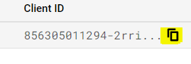
- Go back to NetSuite´s customer account and:
  - Setup/Company/General Preferences
  - Click on subtab Custom Preferences
  - On the “Google Oauth Client ID” under the subsection SC Google Tag Manager Editor, paste the Client ID
856305011294-2rriifcqve8mggg2v0l14f1fd8m9h8bs.apps.googleusercontent.com
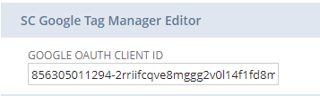
- Hit save
- Go to Commerce -> Websites -> Configuration and pick the corresponding site
  - Integrations -> Google Tag Manager
  - In Google Tag Manager ID field, paste the GTM ID (Make sure no space is added)
  - Press save
- Also, in shopping catalog add:
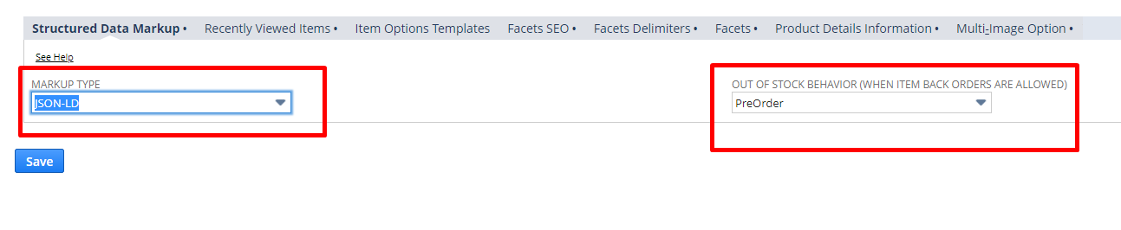

Integrating the services: Tracking tools & Live chats
At first, we´ll integrate the GTM triggers and variables that were built for SuiteCommerce + the GA integration. In consecutive versions (GTM has version controlling), we´ll integrate the rest of the services.

- Access the customer´s NetSuite account: Setup/SuiteCommerce Advanced/Google Tag Manager Editor
- Hit Sign in with Google
  - Sometimes it´ll ask for permissions, hit approve
  - Select your Oracle email
- Under Accounts & Containers – Google Tag Manager Editor, select the customer´s account from the dropdown
- Si Integration dice “NO” es probable que tenga errores y te va a marcar un link al costado:
- Select the container from the list, make sure to select one that´s 100% new and clean
- Make sure that the domain is the correct one, in this case needs to be the staging domain. If not, it will throw error, make sure you delete the container and set “Web” to the new one, not “Server” not anything else.
- Make sure GTM has publish rights on the container (Within GTM, give yourself publish rights to that container). Go under user management for the specific container in question, view your account, click on the three dots, choose view users account details and go to the container, and where it says read, click it and then check the boxes for publisher
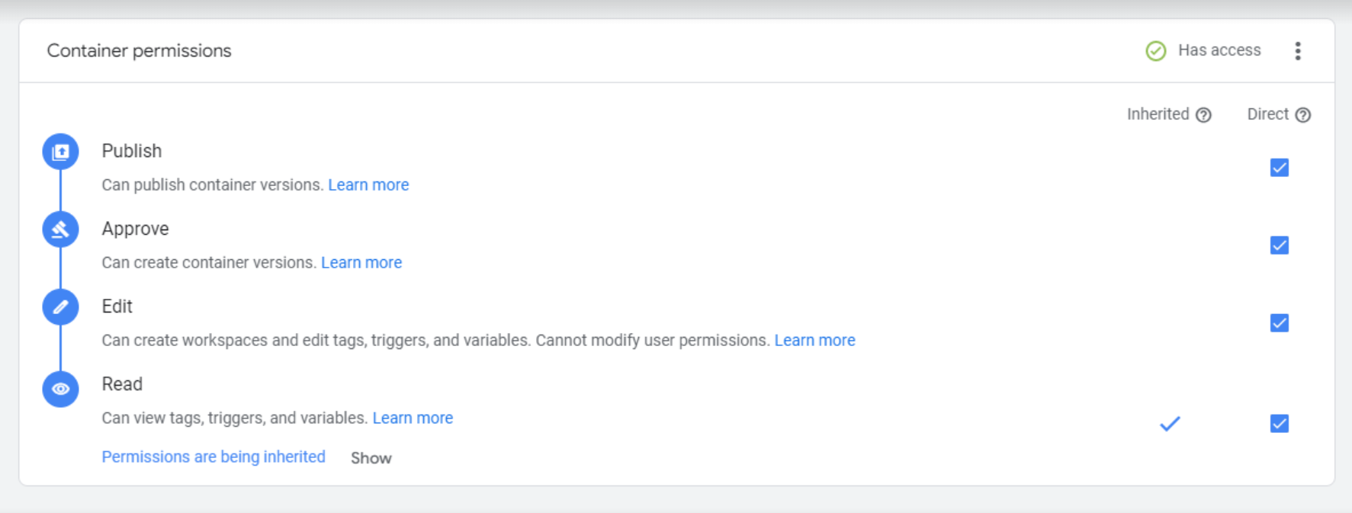
- Into Container Services, within the tag manager editor, select Add Service (Solo para los servicios que usamos, si piden otros servicios hay que contratar horas de dev para hacerlo).
  - On the dropdown menu you´ll select each service. Remember we´ll only add Google Analytics in this version and only later on we´ll add further services
  - On the Field Name, type “GA”. Here´s a reference of the other nomenclatures we utilize:
    - Google Analytics = GA (vuelvo a la tarea y saco el GA ID)
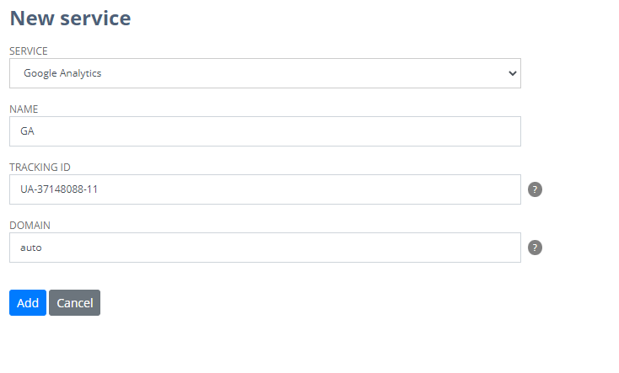
    - Google Ads Remarketing = G Ads Remarketing
    - Google Ads = G Ads Conversion
    - Facebook = FB Pixel
    - BingAds = B Ads
    - LiveChat = LC
    - HotJar = HJ
    - AdRoll = AR
    - AWIN = AWIN
    - ChannelAdvisor = CA
    - Criteo = CRO
    - Google Optimize = GO
    - LivePerson = LP
    - Optimizely = OPY
    - Privy = PRY
    - ShareASale: SAS
    - Talkable = TKE
    - Visual Web Optimizer = VWO
    - Zendesk Chat – Zopim = ZS IQ
    - HubSpot = HS
  - Modify the values on the fields
    - Tracking ID: paste the GA Universal Analytics ID (remember we don´t use GA4)
    - Domain: leave it unmodified (“auto”)
If it asks to install facebook pixel: I enter to the website, and then press on the extension:
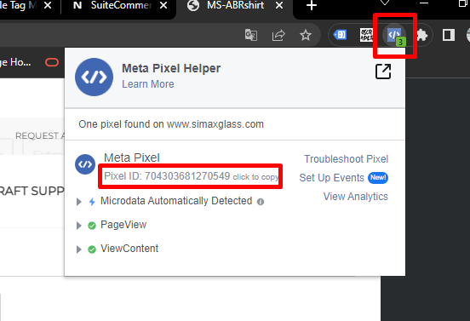
And copy that one, and that’s the one we are going to use for facebook pixel on google tag manager editor.

If it asks to install live chat, I ask the customer for the id

  - Hit “Add”. Note: it´ll take some minutes, do NOT close the tab.
  - Aparece esto:
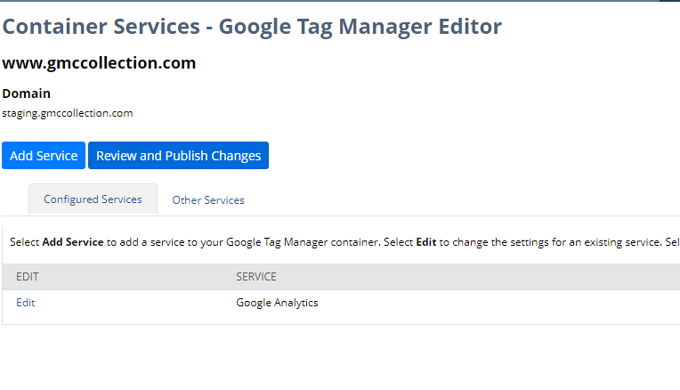
Hago click en review and publish changes
  - Go back to confirm if the service was correctly added, it should appear listed as a service on the tag manager editor.
  - Go to Google Tag Manager and Publish the version (preguntar siempre al cliente por permisos de publicación en el container, sino no se puede publicar esto).
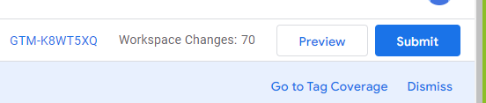
    - For the first version, use the name: “V2 - Native Tags and Google Analytics added”. For further versions, put the name of the service being added IE: “V3 – Google Ads Remarketing”.
    - NOTE: One GTM version per service! This lets you roll back easily if something goes wrong.
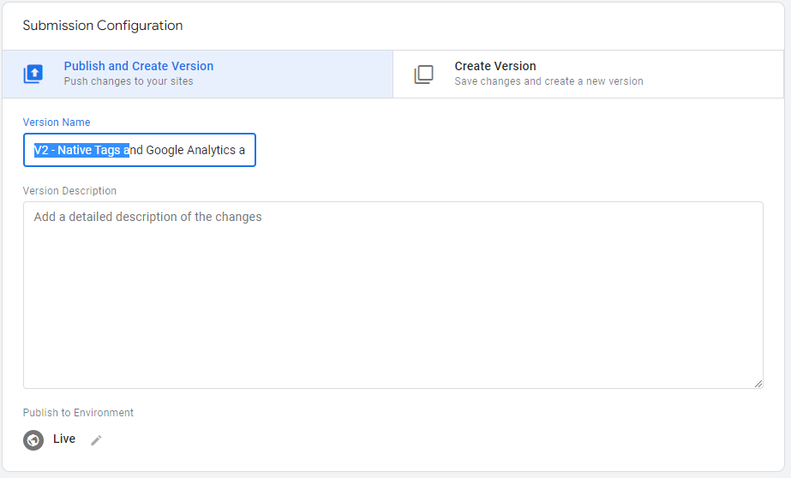
Press publish.
  - Repeat the process service by service
- For Facebook Pixel: Go to Configuration Record: Commerce -> Websites -> Configuration, pick the site, -> Integrations -> Facebook, and paste the application ID there.
- Once this is done, we go to the task:
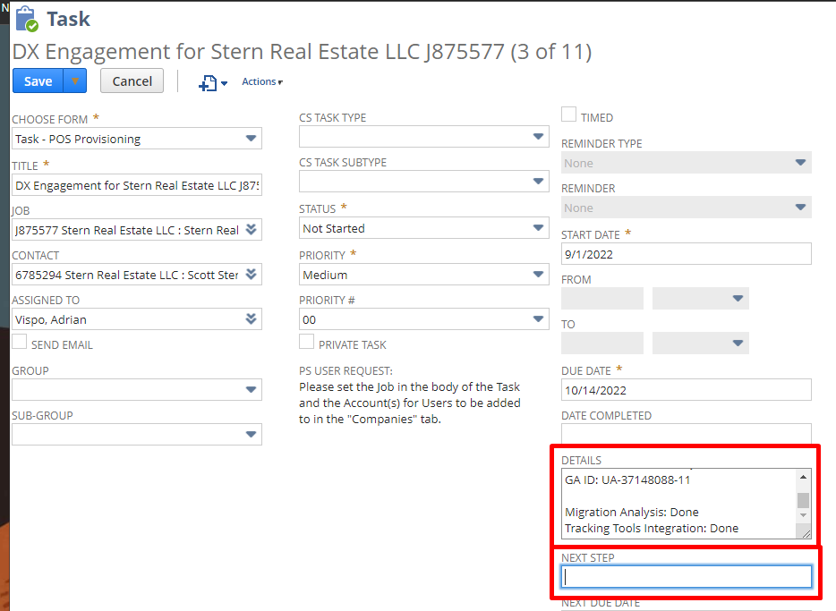
Edit and add:
- Migration Analysis: done
- Tracking Tools Integration: done
Este step es solo para chequear:
Entro al file de suite knowledge de Commerce tasks for DX: https://csnetsuite.custhelp.com/app/answers/answer_view/a_id/1005811

Esto es lo que miro del archivo:
5. DX consultant performs the migration analysis and performs the following:
1. Sends the following via email to the CPM, [PM], DL AND Job Record:
1. Migration analysis recommendations
2. 301 Redirects file for mapping (when applicable)
2. Updates the task record as follows:
1. Assigned to: CPM
2. Next Step: Customer to execute on recommendations & Deliver Mapped 301 Redirects file (If applicable)
3. Next Due Date: Review DX Process Timelines Spreadsheet (to allow sufficient time to review Mapped File and potential iterations)

El next due date, es una semana antes del live, el due date (live) es 10/14/2022, entonces debería ser 10/7/2022, pero en este caso como el cliente tiene que mandar el archivo de mapping ponemos 10 días antes. Y en la parte de assigned to, lo asigno al consultor, en este caso Onkka Brady y save, y listo.

Checking and Preparing Redirects file
(If the site is new, we do not do this part)
At this point, customer sent back the URLs mapped.
        - Save the 301 files from the customer as "Customer - URLs to 301 - [Insert Name of the Project/Customer]"
        - Open the original URLs to 301 file and the Customer File to compare if there are any missing url (row) in the “URLs to 301” tab - check the amount.
Note: if the number of URLs that came back are different from originally sent, check what´s missing.
        - To check that the URLs the customer is utilizing in the URL mapping do exist (meaning, customer is mapping “to” valid pages on the new site), we´ll do the following:
          - On the Project´s folder within Google drive, open "ProjectName Initial-Pre Redirect Checker” and remove the URLs listed below of “Relative URL” and the information on “Destination Status”.
          - Make sure to have the implementation URL without trial slash on cell A2 (Poner la URL de staging de beta, pero luego en el archivo de redirects usaremos el dominio final no el de staging)
          - Copy the New Urls list from the Customer File and paste it on the open file in Drive under “Relative URL” as values only.
          - Once the formulas finishes auto concatenation, go to “Status Checker” and hit Run.
          - Once the script runs, check the HTTP Status response as it´ll return which ones exists/works and which ones doesn´t. Only the ones with 200 will be considered valid. All the others must be re-mapped
            - All URLs returning 4xx, 3xx or 5xx must be corrected
            - If there are less than 50 errors, you can probably fix it for the customer. Common errors:
              - Using full urls (it is an issue only if they are NOT mapping it to an external URL). If it is an internal url only the relative path should be used (remove the domain)
              - Missing forward slash Note: if the url doesn’t have a forward slash, the absolute url will end up looking like https://www.example.comexampleurl which will not work and throw issues.
              - URL is capitalized
              - URLs missing fragments IE: subcategory or parent category (/ropa/buzos pero pusieron /buzos y se comieron ropa).
              - Doesn´t exist (cause customer changed it after URL mapping)
            - If there are over 50 errors, resend to the customer to complete and recheck the URLs until all pass to 200 Status
              - Copy the Destination Status list from Drive into column D of the customer file and highlight the ones with a status does not equal 200 (can even apply a filter to only show only the ones with issues)
        - Once all urls have a Destination Status of 200, we will proceed to prepare the Redirects CSV file:
          - Open the “ProjectName – Redirects” in Drive.
          - Go back to your Customer File in the “URLs to 301” tab, Select both lists (Old URLs and New URLs) and Copy all of them and Paste them as Values in the redirects Drive file positioning yourself in B2 cell.
          - If you've done some fixes you may need to copy/paste your fixes of the Relative url list from the "ProjectName Initial-Pre Redirect Checker” file after you've pasted the values from the customer file on the redirects Drive file to replace the “URL To” list.
          - Use the Final Domain (El dominio final, no el de staging que usaste anteriormente en el pre redirect checker) in the Domain column. Paste it as value on the formula bar while being positioned on A2 cell, remove https and trailing slash e.g.: www.example.com. Once you pasted it you will need to double click on the blue square on the bottom right of the cell.
          - Make sure there are no blank spaces on the relative urls. Select both lists of urls on the redirects Drive file, press CTRL+H and replace blank space “ “ with %20, make sure to click on “Replace all”.
          - Make sure there are no hyperlinks on the file, everything NEEDS TO BE PLAIN TEXT. An easy way to fix this click the space between A and 1 (top left empty space) which will select everything, then right click on it, go to View more row action and finally select Remove link.
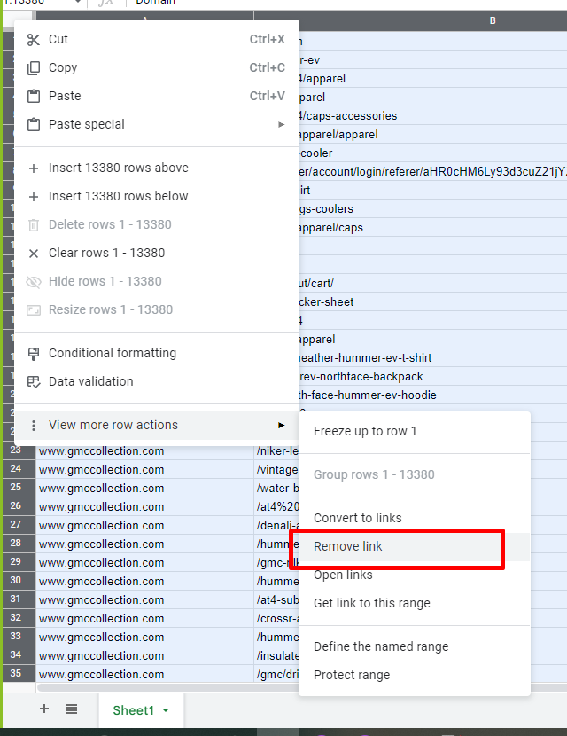
          - Finally go to File> Download> Comma Separated Value (CSV) and replace de Redirects file on the project folder.
            - Name: [Insert Name of the Project/Customer] Redirects.csv
        - Send email to FC of the Redirects File
          - Subject- [Insert Project Name and keep brackets] - Redirects CSV
          - Body-
After a great work from [Customer Name] team, here is the CSV file with the redirects.
This file need to be imported during the go-live.
If you have any doubts, please, don’t hesitate to contact me.
          - Attachment- [Insert Name of the Project/Customer] Redirects.csv

Pre Go-Live Checkpoint
There are two possible paths: Open Site and Closed Site (full password protected)
Open Site: (If the site is new, we do not redirects file part)
It is a quality assurance check from the perspective of migration, redirects, SEO, tracking tools, etc.

- Preparing the Pre Go-Live Checkpoint email:
- Create a new email in your Email Software (IE: Outlook), based on another Pre Go-Live Checkpoint email sent
    - To: CPM or FC/PM
    - Subject: (Project’s Name) – Internal / Initial or After fixes or Final / Pre Go-Live Checkpoint
      - Initial: when the checkpoint was realized for the first time and it failed (has blockers)
      - After fixes: when the checkpoint was realized more than once and it failed (still has blockers)
      - Final: when the checkpoint was realized and it was successful (no blockers, it’s allowed to go live)
  - Modify the body:
Introduction:

- Modify the CPM name accordingly.
- Modify the introduction message based on the type of Pre Go-Live Checkpoint:
  - If Initial: Here’s the initial Pre Go-Live Checkpoint
  - If After Fixes: Here’s the Pre Go-Live Checkpoint after fixes
  - If Final: Here’s the final Pre Go-Live Checkpoint
- Modify site name: IE “Site: www.example.com”
- Modify the domain where we are doing the checkpoint: IE “Domain: http://example.production.na1.netsuitestaging.com/” Note: Pre Go-Checkpoints must be done in the implementation/testing/staging URL. USO EL DOMINIO DE TESTING
- Safe Harbor note should not be modified.
Implementation status:

This section will indicate the types and quantity of status found.
Implementation status are:

- Blockers: Projects aren´t allowed to Go Live with "blockers". Blockers are considered a critical risk for customer revenue.
- Warnings: if applies only in certain situations. Projects can go live but the warnings must be fixed.
- Recommendations: optimization actions should be taken or sent to the customer. Projects can go live with recommendations.
- Passed: succeed tests.

Conclusion:

- Modify the conclusion message. It could be:
  - First part:
    - This project has no blockers
    - This project has one blocker
    - This project has two blockers
    - This project has multiple blockers
  - Second part:
    - There are no recommendations.
    - There is one recommendation to be driven to the customer as a Pre go-live optimization action.
    - There are recommendations to be driven to the customer as Pre go-live optimization actions. Note: if the checkpoint succeeds (Final), it should say “Post go-live optimization actions”
- Modify the Go Live Status. It could be:
  - Ready: the project can go live
  - Not ready: the project is blocked. It can’t go live.
- Modify Redirects. (If the site is new, we do not do this part). It could be:
  - Ready: redirects are working correctly. To check this, we should follow the Check and Preparation of Redirects File Guide.
    - Attach the redirects file
    - Add “Attached is the CSV file with the redirects. This file need to be imported during the go-live. If you have any doubts, please, don’t hesitate to contact me.”.
  - Not ready: redirects aren’t functional or couldn’t be checked due to the customer didn’t do the mapping.
    - Attach the migration email we sent before (not the “URLs to 301” file but the email itself)
    - Add a note explaining why redirects are not ready. For instance:
      - Note: Analysis was sent today (or yesterday or past week, etc) @CPM to follow up with the customer
      - Note: Customer didn’t sent the mapping back @CPM to follow up with the customer

Content:

This section is divided into Global and Types of pages. In the Global section, we include the security status (HTTPS environment) and global errors related to the SEO engine. In the types of pages section, we list each type of page, the metadata status (page title and meta description), and specific errors related to the SEO engine. We do this check with the staging or testing domain: beta.cheesepeake.coffee
We should include:

- Tested element and what we found
- Status: it could be Blocker, Not optimal (recommendation) or Ok (passed).
- Action (if blocker) or recommendation (if Not optimal).
- Owner: refers to who is going to implement the action or recommendation.
- Load Time (only when reporting SEO Engine).

Examples:
- Meta Description: Filled up
  - Status: Ok

- Meta Description: All categories have it empty
  - Status: Not optimal
  - Recommendation: Populate meta descriptions in all categories with content that differs from title, that is unique for each category and it can be up to 160 characters. In plain text format.
  - Owner: Customer

- Meta Description: Empty
  - Status: Blocker
  - Action: Populate meta description with content that differs from title, that is unique for this page and it can be up to 160 characters
    - Use: Customer name offers everything a true example needs. Select from example supplies, example supplies, example supplies and example at affordable prices.
  - Owner: Customer

Check preparation:

- Open an incognito window
- Open the pages to test:
  - Homepage
  - Blank search (/search)
  - 3 categories
  - 3 subcategories (if exist)
  - 3 sub-sub categories (if exist)
  - 3 items
  - Landing pages (taken from navigation tab and footer)
- In each page, we have to open View Source (“right click > view page source” o “CTRL + U”)
- Add to the final of each URL this parameter: ?seodebug=T&preview=23456 (Preview number should be changed each time for a new random number).
  - For ERP version 2023.2 add ‘&forceseo=T’. Changed so the engine now only runs for bots and not humans

Types of checks:

- Page title: must be the same or better than the current one. All pages (other than the Homepage) should have the same title structure. Note: it will be a blocker if the page title says Shopping, Internal Error, Page Not Found or Welcome to the Store.
- Canonical Tag: the URL in this tag must be the same as on the URL tab.
- Meta description: must be the same or better than the current one. In addition, it must be different from the title and must be at least 100 characters long.
- Schema markup: (only on PDP page) we check if it’s generated. If not, we must set it up on the Configuration record:
        - Go to the customer NetSuite backend
        - Commerce / Websites / Configuration
        - Select the corresponding website and the implementation URL. Select Configure
        - Go to Shopping Catalog tab
        - Go to Structure Data Markup subtab
          - In Markup Type select “JSON-LD”
          - In Out of Stock Behavior select “InStock”.
          - Save
- Div “main”: it should not be empty
- /footer: It should we present, we use it as a verification that div main is complete.
- Error search: we search for some words that could indicate SEO engine errors: error, undefined, deprecated, typeError, debug.
- SEO Engine execution time:
        - If the average execution time is less than 6,000 ms, it is OK.
        - If the average execution time is between 6,000 and 8000 ms it is Not optimal
        - If the average execution time is more than 8,000 ms it is a Blocker

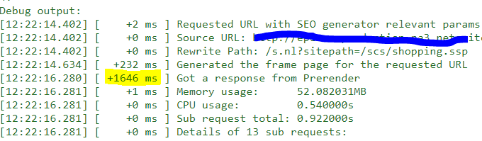

Checks to run:

- Homepage:
        - Do the test 3 times (by changing the preview number)
        - 1st: do the full test
        - 2-3: Only check "Error" and "Execution Time"
          - Add the three execution times and divide by 3 to obtain the average load time.
        - Title/Meta-description content on the new site should be the same or better than that on the old site
- Blank search:
        - Do not check title or meta description
        - Do the test 3 times
        - 1st test: Canonical, div main, 'noindex, nofollow'
        - 2-3: Only check "Error" and "Execution Time"
          - Add the three execution times and divide by 3 to obtain the average load time.
- Categories & Subcategories, PDP/Items, Landing Pages – One time on each we opened
        - Page title
        - Meta description
        - Canonical
        - Schema markup (only on PDP)
        - div main / body
        - noindex, nofollow
        - "Error"
        - Record execution time

Tracking codes:
This section will indicate the tracking services and chat services integrated into the implementation site. For each, we should indicate the service name, if it was installed or not and the service ID. If the service wasn’t installed yet, we should indicate how to proceed to execute the action and the owner of that action.

Examples:

Installed:
- Google Analytics:
  - Status: Installed
  - ID: UA-XXXXXXX-X
- Google Ads Conversion:
  - Status: Installed
  - Conversion ID: XXXXXXXXXX
  - Conversion Label: XXXXXXXXXXXXXXXXX

Not installed:
- Google Analytics:
  - Status: Not Installed / Blocker
  - ID: UA-XXXXXXX-X
  - Action: Pending on customer to create GTM and provide access
  - Owner: Customer
- Google Ads Conversion:
  - Status: Not Installed / Blocker
  - Conversion ID: XXXXXXXXXX
  - Conversion Label: XXXXXXXXXXXXXXXXX
  - Action: CPM to provide NetSuite Backend access
  - Owner: NetSuite
- Facebook pixel:
  - Status: Not Installed / Blocker
  - ID: XXXXXXXXXX
  - Action: CPM to provide NetSuite Backend access and customer created GTM but didn’t provide access
  - Owner: NetSuite and Customer

- Updating Task
Depending on the results of the Pre-Go Live checkpoint you will update the job record as follows:
- No errors were found
  - Next Step: Post Go-Live Checkpoint
  - Next Due Date: The day before going live
  - The task remains assigned to you

- Errors where found:
  - Next Step: Fix Pre-Go Live Blockers
  - Next Due Date: The day before going live
  - Assignee: CPM

Closed Site:
It is a quality assurance check from the perspective of tracking tools, domains and preventing the indexing of the site through robots.txt and Switch 17.
- Preparing the Pre Go-Live Checkpoint email:

- Create a new email in your Email Software (IE: Outlook), based on another Pre Go-Live Checkpoint email sent
    - To: CPM or FC/PM
    - Subject: (Project’s Name) –Initial or After fixes or Final / Pre / DX Action Items
      - Initial: when the checkpoint was realized for the first time and it failed (has blockers)
      - After fixes: when the checkpoint was realized more than once, and it failed (still has blockers)
      - Final: when the checkpoint was realized and it was successful (no blockers, it’s allowed to go live)
  - Modify the body:
Introduction:

- Modify the CPM name accordingly.
- Modify the introduction message based on the type of Pre Go-Live Checkpoint:
  - If Initial: Here’s the initial Pre Go-Live Checkpoint
  - If After Fixes: Here’s the Pre Go-Live Checkpoint after fixes
  - If Final: Here’s the final Pre Go-Live Checkpoint
Actions:

- “Confirm which will be the domain where the site will live (FC or CPM / Customer)” we must confirm the domain where the customer will go live. The status could appear as Done or Pending. If Done, we should add a sub-bullet point with the domain. If Pending, we should add in a sub-bullet point that CPM or FC must follow up with the customer.
- “Provide implementation url (FC or CPM / Customer)” we must confirm the implementation URL. The status could appear as Done or Pending. If Done, we should add a sub-bullet point with the URL. If Pending, we should add in a sub-bullet point that CPM or FC must provide it.
- Create and/or provide access to a GA property for the new site (Customer)” we must confirm if the Google Anayltics property is created and if we have access to it. The status could appear as Done or Pending. If Done, we should add a sub-bullet point with the property ID. If Pending, we should add in a sub-bullet point that Customer must create the property or/and provide access.
- “Create and/or provide access to a GTM container for the new site (Customer)” we must confirm if the Google Tag Manager container is created and if we have access to it. The status could appear as Done or Pending. If Done, we should add a sub-bullet point with the container ID. If Pending, we should add in a sub-bullet point that Customer must create the container or/and provide access.
- “Grant backend access for DX (FC or CPM)” we must confirm if we have access to NetSuite Backend. The status could appear as Done or Pending. If Done, nothing should be added. If Pending, we should add in a sub-bullet point that CPM or FC must provide access.
- “Configure GA and GTM (DX)” we must confirm if tracking tools are integrated. The status could appear as Done or Pending. If Done, nothing should be added. If Pending, we should add in a sub-bullet point the reason why we didn’t integrate tracking tools yet. (i.e.: “Depends on backend access blocker” o “Depends on GTM access”).
- “Modify robots.txt to Disallow: / (DX)” we must confirm if robots.txt is configured to prevent the indexing of the site. Robots.txt should be configured as:
User-agent: *
Disallow: /
The status could appear as Done or Pending. If Done, nothing should be added. If Pending, we should add in a sub-bullet point the reason why it is not configured (i.e.: “Depends on backend access blocker”)

How to check robots.txt?
- Go to the implementation URL and add “/robots.txt” at the end
- If it says “Allow: ”, “Allow: /” o “Disallow: ” it is because it is not configured. If it appears as indicated above, it is correctly configured.

How to configure robots.txt?
- Go to customer NetSuite backend
- Documents / Files / File cabinet
- Click on Web Site Hosting Files.
- Click on Live Hosting Files
- Click on Add file (top left) and select the robots.txt file located on the local folder of the project. Import it.
- “Fill up support case on behalf of the customer requesting to “Enable Switch 17” to disable the SEO Engine only for this specific website record and not whole account. (FC or CPM)” we must confirm if Switch 17 is enabled. The status could appear as Done or Pending. If Done, nothing should be added. If Pending, we should add in a sub-bullet point the reason why it is not enabled (i.e.: “Depends on backend access blocker”).
How to check if Switch 17 is enabled?
      - Go to implementation URL
      - Open View Source
      - Add to the final of each URL this parameter: ?seodebug=T&preview=23456 (Preview number should be changed each time for a new random number)
      - Verify if SEO engine is not executed.

  - Mail closure:
We must indicate the project status. It could be:
- Site has (a) pending item(s) to be cleared before going live
- Site has no pending items and they are ready to go live

- Updating Task
Depending on the results of the Pre-Go Live checkpoint/ DX Action Items, you will update the job record as follows:
- No pending items
  - Next Step: Post Go-Live Checkpoint
  - Next Due Date: The day before going live
  - The task remains assigned to you

- Still pending items:
  - Next Step: Clear the pending items
  - Next Due Date: The day before going live
  - Assignee: CPM
Post Go-Live Checkpoint

Like Pre Go-Live Checkpoint, this is a quality assurance check from the perspective of migration, redirects, SEO, tracking tools, etc.

Open Site:
- Preparing the Post Go-Live Checkpoint email:

- Create a new email in your Email Software (IE: Outlook), based on the final Pre Go-Live Checkpoint email sent
    - To: CPM or FC/PM
    - Subject: (Project’s Name) – Internal / Initial or After fixes or Final / Post Go-Live Checkpoint
      - Initial: when the checkpoint was realized for the first time and it failed (has issues)
      - After fixes: when the checkpoint was realized more than once, and it failed (still has issues)
      - Final: when the checkpoint was realized and it was successful (no issues, it’s healthy)
  - Modify the body:

Introduction:

- Modify the CPM name accordingly.
- Modify the introduction message based on the type of Post Go-Live Checkpoint:
  - If Initial: Here’s the initial Post Go-Live Checkpoint
  - If After Fixes: Here’s the Post Go-Live Checkpoint after fixes
  - If Final: Here’s the final Post Go-Live Checkpoint
- Modify site name: IE “Site: Example Site”
- Modify the domain where we are doing the checkpoint: IE “Domain: https://www.exameple.com” Note: Post Go-Checkpoints must be done in the live site. Se tiene que hacer en su dominio FINAL.
- Safe Harbor note should not be modified.
Implementation status:

This section will indicate the types and quantity of status found.
Implementation status are:

- Issues: problems were detected after going live. Issues are considered a critical risk for customer revenue.
- Warnings: if applies only in certain situations. The warnings must be fixed.
- Recommendations: Improvements that customer can take it or not.
- Passed: succeed tests.

Conclusion:

- Modify the conclusion message. It could be:
  - First part:
    - This project has no issues
    - This project has one issue
    - This project has two issues
    - This project has multiple issues
  - Second part:
    - There are no recommendations.
    - There is one recommendation to be driven to the customer as a Post go-live optimization action.
    - There are recommendations to be driven to the customer as Post go-live optimization actions.
- Modify the Go Live Status. It could be:
  - Healthy: the project is live in good conditions.
  - Not healthy: the project is live with issues.
- Modify Redirects. It could be:
  - Working: redirects were imported, checked, and are working correctly.

How to check redirects? (If the site is new, we do not do this part)

    - Go to the project folder in Google Drive and open “NameOfTheProject Post Redirect Checker” and “NameOfTheProject Redirects” files.
    - Copy the list of URLs (below “URL from”) from file “NameOfTheProject Redirects” and paste it in cell A5 (below “Relative URL”) in the “NameOfTheProject Post Redirect Checker” file. (CTRL + Shift + Down)
    - Cuando nos pide el dominio, ponemos el dominio live, es decir por ejemplo:
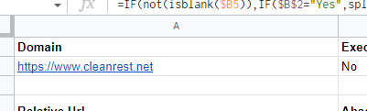
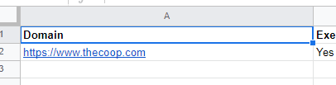
En vez de staging.thecoop.com

    - Go to cell C5 and double click on the blue square on the bottom right.
    - Go to “Execute Status Script” on the B2 cell and select Yes.
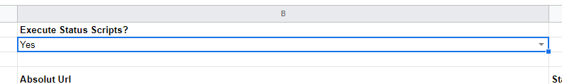
    - If redirects are working correctly, all status should be 200 (green). If there are other status 30x, 40x or 50x, revise each and, if needed, fix the redirect in NetSuite Backend:
(301 -> 404 el redirects funciona, la URL a la que redirige no existe. O el cliente crea esa página o se cambia el redirect). Esto se lo pongo en el mail, en la parte de redirect, y ahí le pego la dirección, y poner “this directions go to 404, que el cliente la cree o que la rediriga a la homepage a otra, que la mapee para no perder el tráfico).

      - Go to Commerce / Hosting / Redirects y find the redirect to fix.
      - Go to Edit, fix it and then click on Save.
    - Once all redirects are working correctly, go to B2 cell and select No to pause the script.
      - Other, put on the email “This directions go to 404, client needs to create them or redirect them to homepage to not lose traffic”
Las que esten en “error” que redirige muchas veces, es porque la URL tiene el redirect a si mismo y entra en un loop infinito.
  - Not working: redirects aren’t functional or couldn’t be checked due to the customer didn’t do the mapping.
    - Add a note explaining this status. For instance:
      - Note: Redirects weren’t imported yet, @CPM to follow up with the customer
      - Note: Customer didn’t send the mapping back @CPM to follow up with the customer

Content:

This section is divided into Global and Types of pages. In the Global section, we include the security status (HTTPS environment) and global errors related to the SEO engine. In the types of pages section, we list each type of page, the metadata status (page title and meta description), and specific errors related to the SEO engine. Correr el SEO: en cada página click derecho -> view page source o Ctrl + U y luego en la url pegamos ?seodebug=T&preview= con un numero nuevo cada vez.
- For ERP version 2023.2 add ‘&forceseo=T’. Changed so the engine now only runs for bots and not humans

We should include:

- Tested element and what we found
- Status: it could be Issue, Not optimal (recommendation) or Ok (passed).
- Action (if Issue) or recommendation (if Not optimal).
- Owner: refers to who is going to implement the action or recommendation.
- Load Time (only when reporting SEO Engine).

Examples:
- Meta Description: Filled up
  - Status: Ok

- Meta Description: All categories have it empty
  - Status: Not optimal
  - Recommendation: Populate meta descriptions in all categories with content that differs from title, that is unique for each category and it can be up to 160 characters. In plain text format.
  - Owner: Customer

- Meta Description: Empty
  - Status: Issue
  - Action: Populate meta description with content that differs from title, that is unique for this page and it can be up to 160 characters
    - Use: Customer name offers everything a true example needs. Select from example supplies, example supplies, example supplies and example at affordable prices.
  - Owner: Customer

Check preparation:

- Open an incognito window
- Open the pages to test:
  - Homepage
  - Blank search (/search)
  - 3 categories
  - 3 subcategories (if exist)
  - 3 sub-sub categories (if exist)
  - 3 items
  - Landing pages (taken from navigation tab and footer)
- In each page, we have to open View Source (“right click > view page source” o “CTRL + U”)
- Add to the final of each URL this parameter: ?seodebug=T&preview=23456&forceseo=T (Preview number should be changed each time for a new random number)

Types of checks:

- Page title: must be the same or better than the current one. All pages (other than the Homepage) should have the same title structure. Note: it will be a blocker if the page title says Shopping, Internal Error, Page Not Found or Welcome to the Store.
- Canonical Tag: the URL in this tag must be the same as on the URL tab.
- Meta description: must be the same or better than the current one. In addition, it must be different from the title and must be at least 100 characters long.
- Schema markup: we check if it’s generated. If not, we must set it up on the Configuration record:
        - Go to the customer NetSuite backend
        - Commerce / Websites / Configuration
        - Select the corresponding website and the implementation URL. Select Configure
        - Go to Shopping Catalog tab
        - Go to Structure Data Markup subtab
          - In Markup Type select “JSON-LD”
          - In Out of Stock Behavior select “InStock”.
          - Save
- Div “main”: it should not be empty
- /footer: we use it as a verification that div main is complete.
- Error search: we search for some words that could indicate SEO engine errors: error, undefined, deprecated, typeError, debug.
- SEO Engine execution time:
        - If the average execution time is less than 6,000 ms, it is OK.
        - If the average execution time is between 6,000 and 8000 ms it is Not optimal
        - If the average execution time is more than 8,000 ms it is a Blocker



Checks to run:

- Homepage:
        - Do the test 3 times (by changing the preview number)
        - 1st: do the full test
        - 2-3: Only check "Error" and "Execution Time"
          - Add the three execution times and divide by 3 to obtain the average load time.
        - Title/Meta-description content on the new site should be the same or better than that on the old site
- Blank search:
        - Do not check title or meta description
        - Do the test 3 times
        - 1st test: Canonical, div main, 'noindex,nofollow'
        - 2-3: Only check "Error" and "Execution Time"
          - Add the three execution times and divide by 3 to obtain the average load time.
- Categories & Subcategories, PDP/Items, Landing Pages – One time on each we opened
        - Page title
        - Meta description
        - Canonical
        - Schema markup
        - div main / body
        - noindex, nofollow
        - "Error"
        - Record execution time

Tracking codes:
This section will indicate the tracking services and chat services integrated into the implementation site. For each, we should indicate the service name, if it was installed or not and the service ID. If the service wasn’t installed yet, we should indicate how to proceed to fix the issue and the owner of that action.

Examples:

Installed:
- Google Analytics:
  - Status: Installed
  - ID: UA-XXXXXXX-X
- Google Ads Conversion:
  - Status: Installed
  - Conversion ID: XXXXXXXXXX
  - Conversion Label: XXXXXXXXXXXXXXXXX

Not installed:
- Google Analytics:
  - Status: Not Installed / Issue
  - ID: UA-XXXXXXX-X
  - Action: Pending on customer to create GTM and provide access
  - Owner: Customer
- Google Ads Conversion:
  - Status: Not Installed / Issue
  - Conversion ID: XXXXXXXXXX
  - Conversion Label: XXXXXXXXXXXXXXXXX
  - Action: CPM to provide NetSuite Backend access
  - Owner: NetSuite
- Facebook pixel:
  - Status: Not Installed / Issue
  - ID: XXXXXXXXXX
  - Action: CPM to provide NetSuite Backend access and customer created GTM but didn’t provide access
  - Owner: NetSuite and Customer

- Additional checks:
Domains hosted:

- Go to Commerce / Hosting / Domains and check that all the necessary domains are hosted in NetSuite.
  - If migrating a subdomain, check that it is hosted
  - If migrating a root domain, www and root domain should be hosted
  - If migrating a www, root domain and www should be hosted
  - If migrating another domain, the old and the new domains should be hosted.
- Only the primary domain should be hosted as “Single Domain for Web Store and Checkout”.
- No domain should be hosted as “Redirect URL”
- Make sure that all domains are hosted correctly:
  - If secure, it should be hosted as “Secure Web Store” (excluding primary domain as we see before)
  - If non-secure, it should be hosted as “Web Store Only”
- In case you found a missing domain or an error, include it on the Post Go-Live email conclusion.

Primary Domain:

- Go to Commerce / Websites / Websites List and select Edit in the corresponding website
- Go to Domains tab
- In the Shopping Domains list, make sure that the primary domain box is checked correctly. If not, contact CPM.

Sitemap:

Configure Sitemap generation:
- Go to Commerce / Marketing / Sitemap Generator
- Click Edit in the live domain
- In the Sitemap Content tab, into Pages to Generate, click on the checkbox “SMT Landing Pages”.
- In the Scheduling tab, click on the checkbox “Enable scheduling of sitemap generation”. In Frequency, select Weekly and Sunday.
- Click on Save.

Sitemap generation:
- Go to Commerce / Marketing / Sitemap Generator
- Click on the checkbox of the live URL
- Click on Generate Sitemap
- Reload page
- Click on Sitemap files. That file cabinet should include:
  - Index sitemap
  - Unique sitemap (the one with the ID)
  - Google verification file (add it from the local project folder)
- 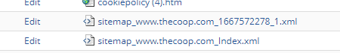

Para el Google verification file, si no lo tengo y lo tengo q hacer una vez, entro a search console:
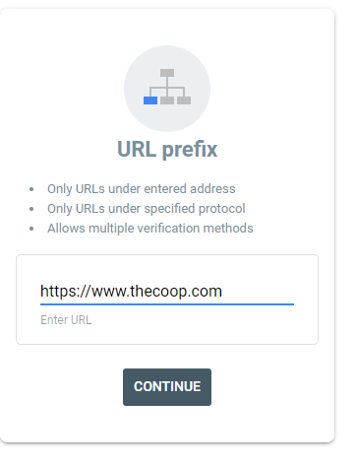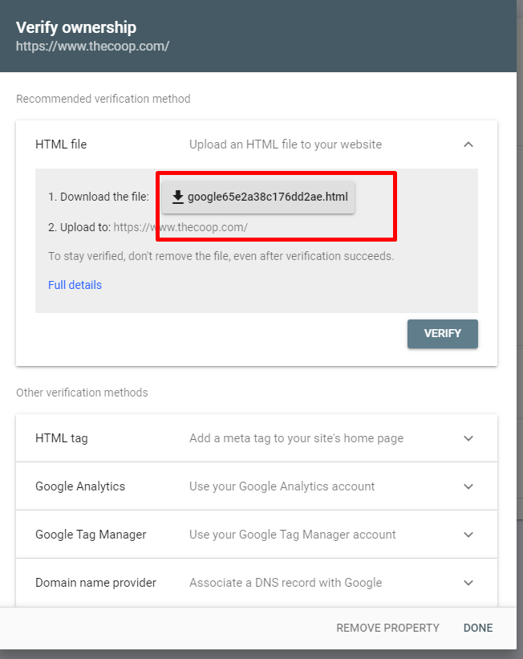
Esto lo hago con el live de cada sitio, y además el archivo html lo tengo que tener en todas las carpetas locales de proyectos. (carpeta local y carpeta en drive tenia desde el principio). Es el mismo archivo siempre para todos. En trabajo -> sites -> DX PS -> sitio SRE-GMC o HCS u otro proyecto, va a estar el mismo archivo para todos.

Lo tengo que subir al file cabinet luego para verificar. Si no lo agrego, el verificado me va a tirar error.
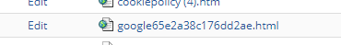
Una vez subido, toco verificar:
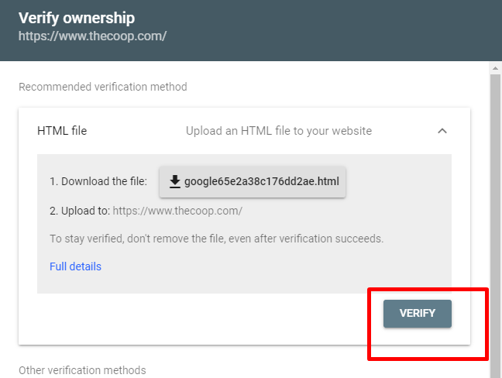

Submit Sitemap: (Estos son los pasos mencionados anteriormente).
- Go to Google Search Console (https://search.google.com/search-console/) (Aprieto continue habiendo puesto el sitio live y pongo continue y luego go to property)
- Go to Properties dropdown (top left) and select Add Property
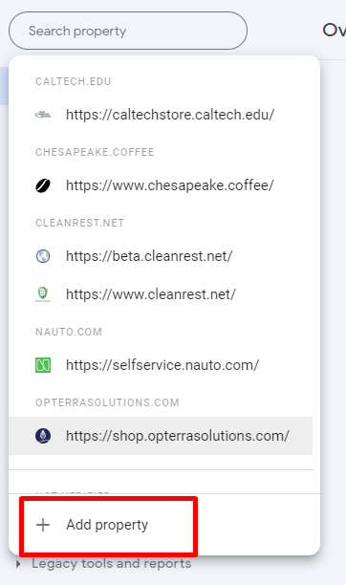
- Inside the popup, in the URL Prefix field, paste the live domain i.e.: https://www.example.com/. Click on Continue.
- Inside the confirmation popup, click on Go to property.
- Select Sitemaps (left menu)
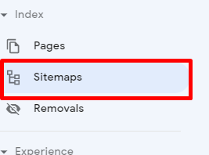
- Copy the name of the Unique sitemap file (the one with the ID) from the file cabinet and paste it in Google Search Console, in Enter Sitemap URL field. Click on Submit. (Example: sitemap_www.thecoop.com_1667572278_1.xml)
- Copy the name of the Sitemap Index file from the file cabinet and paste it in Google Search Console, in Enter Sitemap URL field. Click on Submit.
- Make sure that both sitemaps have the Success status
- Si no dice success, es probablemente porque el robots.txt esta como disallowed, al no permitir a ningún robot examinar, por eso no lo puede leer.
- Once everything is correctly set up, we should remove the Unique Sitemap file from the Submitted Sitemaps in Goole Search Console
- 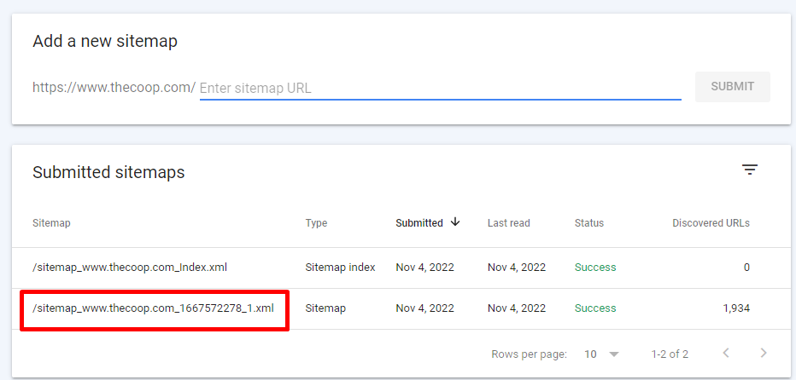
- El unique es el que tiene número, y dentro del de arriba de index, debería estar el unique, entro me fijo y está.
  - Click on the Unique Sitemap (entro en el marcado, y a la derecha tiene los 3 puntitos una vez que entre).
  - Go to the three black points located in the top right
  - Click on Remove Sitemap and the click on remove on the popup.

robots.txt:

- We must confirm if robots.txt is configured to allow crawlers to access to the site. Robots.txt should be configured as:
User-agent: *
Allow: /

How to check robots.txt?
- Go to the site URL and add “/robots.txt” at the end
- If it says “Allow: ”, “Disallow: /” or “Disallow: ” it is because it is not configured. If it appears as indicated above, it is correctly configured.
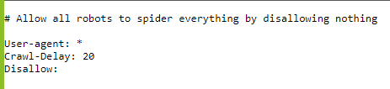
Tiene que estar como allow, no tiene que prohibir nada.

How to configure robots.txt?
- Go to customer NetSuite backend
- Documents / Files / File cabinet
- Click on Web Site Hosting Files.
- Click on Live Hosting Files
- Click on Add file (top left) and select the robots.txt file located on the local folder of the project. Import it. (para password protected es siempre disallow /)
  - If customer has more that one site in the same NetSuite account, the robots.tx file for our project should be named “nameofthesite_robots.txt”. Then, we should create a redirect from “/robots.txt” to “nameofthesite_robots.txt”.
    - Go to Commerce / Hosting / Redirects and click on New.
What do we fill up here?
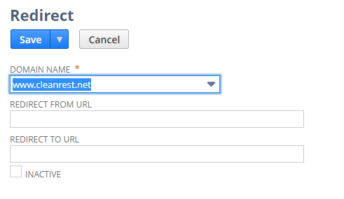
Google Search Console and Google Analytics configuration:

Google Search Console:
Dentro de google search console.
If the Post Go Live Check succeeded, we should request the indexing of the pages.
- Go to URL Inspection (left menu) and paste the live site URL (https://www.example.com/). Click on Enter
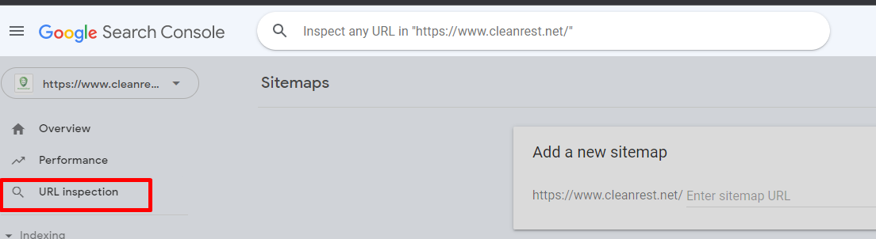
- Click on Test Live URL (to make sure that Google is not checking a cache version)
- Presiono aquí:
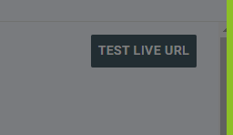
- If everything appears as green (or grey if it is a new site) on the next window, click on Request indexing.
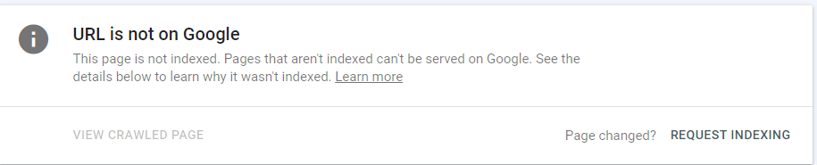
Acá estaba live en store.thecoop.com, entonces tenes que pedirle que indexe en www.thecoop.com.
- Click on Got it
Link the Google Search Console property to the Google Analytics property.
- Go to Settings (left menu) and click on Associations.
- Click on Associate and paste the Google Analytics Property ID to associate. Select the correct one and click on Continue
- Confirm the association

Provide the customer with access.
- Go to Settings (left menu) and click on Users and permissions.
- Go to the Google Tag Manager/Admin/User Management and copy user’s emails with access.
- Go back to Google Search Console and click on Add User. Paste the emails and provide them with:
  - Owner: if they are part of the company
  - Full: for other domains
  - Restricted: mails that in GTM don’t appear as Administrator.
- Click on Add

Google Analytics: Abro Google analytics

(esto ya lo habíamos hecho en el tracking tools integration, cuando viene de un sitio que muda al mismo dominio, no hay que hacer mucho, si hay que chequear la default URL si se cambian de un dominio a otro)

Set a note that indicates the go live date.
- Go to Audience / Overview (left menu)
- Make sure that the date range selector includes the go live date.
- Below the graphic, there is an arrow point down. Click there and then click on Create New Annotation.
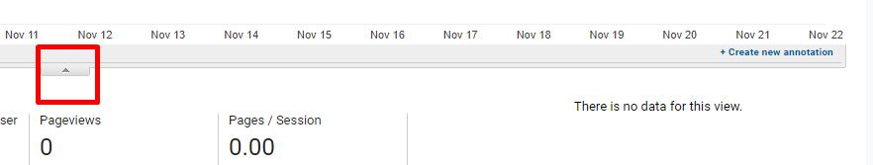
- A date range selector will be displayed. Select the go live date
- On the text box, write “SC or SCA (what applies) Live”.
- Make sure that in the Visibility section, the Shared box is checked.
- Click on Save.

Verify and adjust Google Analytics configurations.

At Property level:
- Property Settings:
  - Property Name: We must check the name is appropriate according to the site/project we’re working on. DO NOT modify it if there´s more than one site being tracked
IE: If the name says “NetSuite Test” we should modify it for the project name or customer name
As long as the old Domain is going away, we should update/edit this setting. Appropriate would be to request the client to do so.
  - Default URL:
    - There´s a selector for http and https, which means: the second field MUST NOT contain the protocol. The second field is for the hostname (domain+subdomain, without trial slash and without protocol)
    - The configuration should be for the “new” site (so likely HTTPS, likely with WWW, etc) and may not necessarily match at 100% with the old domain´s configuration (might be http, might be root domain, etc).
    - If it’s a new site, just make sure to use the proper protocol and (sub)domain
    - As long as the old Domain is going away, we should update/edit this setting. Appropriate would be to request the client to do so.
  - Default View: do not modify if multiple sites are being tracked on the same property.
If there´s nothing selected: select the view that makes more sense – ideally one that´s not filtered.
  - Industry category: select the one that makes more sense. This is not mandatory though.
  - Enable Demographis and Interest reports: Yes, if possible
  - Enable User Metric in Reporting: Yes, if possible
  - Save.
- Tracking Info / Referral Exclusion List:
  - Check that the root domain is listed. For new properties/new domains, this is frequently automatic
  - To add a new root domain into it, hit the “+ Add Referral Exclusion” and type the root domain.
  - Add the other following excludable domains: netsuite.com, netsuitestaging.com which are in order to avoid referrals from those sources (frequently utilized for testing purposes)
  - Add the NEW Live domain also

At View level:
- View Settings:
  - View Name:
    - Check that the name makes sense for the project at hand. DO NOT modify if its being utilized for more than one site
    - As long as the old Domain is going away, we should update/edit this setting. Appropriate would be to request the client to do so
  - Website´s URL:
    - This is for THE FINAL site. Select http or https, then type the host name (sub domain or domain, without protocol nor trial slash)
    - As long as the old Domain is going away, we should update/edit this setting. Appropriate would be to request the client to do so
  - Time Zone country or territory.
    - By default Analytics will show US and GMT-08:00. We can keep it this way if we are unsure about customer´s timezone
  - Default Page:
    - always empty at this phase.
  - Exclude URL query parameters:
    - always empty at this phase.
  - Currency Displayed as:
    - By default we´ll see US Dollars. It should be like this in most cases.
  - Bot Filtering:
    - Always selected
  - Site Search Tracking:
    - Enable it.
      - Query Parameter: “keywords”
      - Strip query parameters out of URL: must NOT be enabled
      - Site Search Categories: must NOT be enabled
  - Click on Save

- Ecommerce Settings:
  - Enable Ecommerce:
    - Always enabled
  - Enable Enhanced Ecommerce Reporting:
    - Always enabled
  - Click on Save.

- Google Analytics 4:
Enter property settings -> Modify property details with the name of the site:
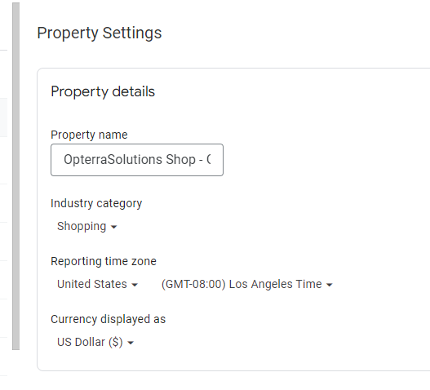

- Updating Task
Once the Post Go-Live Checkpoint was sent, we go back to the Task and update it to Completed.
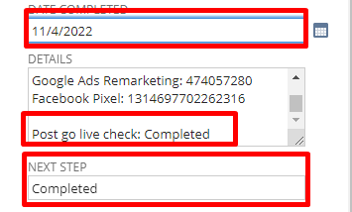

Closed Site:
1. Preparing the Post Go-Live Checkpoint email:
  - Create a new email in your Email Software (IE: Outlook), based on the final Post Go-Live Checkpoint email sent
    - To: CPM or FC/PM
    - Subject: (Project’s Name) – Internal / Initial or After fixes or Final / Post Go-Live Checkpoint
    - Initial: when the checkpoint was realized for the first time and it failed (has issues)
    - After fixes: when the checkpoint was realized more than once, and it failed (still has issues)
      - Final: when the checkpoint was realized and it was successful (no issues, it’s healthy)
  - Modify the body:
Introduction:
- Modify the CPM name accordingly.
- Modify the introduction message based on the type of Post Go-Live Checkpoint:
  - If Initial: Here’s the initial Post Go-Live Checkpoint
  - If After Fixes: Here’s the Post Go-Live Checkpoint after fixes
  - If Final: Here’s the final Post Go-Live Checkpoint
- Modify site name: IE “Site: Example Site”
- Modify the domain where we are doing the checkpoint: IE “Domain: https://www.exameple.com” Note: Post Go-Checkpoints must be done in the live site.Se tiene que hacer en su dominio FINAL.
- Safe Harbor note should not be modified.
Implementation status:

This section will indicate the types and quantity of status found.
Implementation status are:

- Issues: problems were detected after going live. Issues are considered a critical risk for customer revenue.
- Warnings: if applies only in certain situations. The warnings must be fixed.
- Recommendations: Improvements that customer can take it or not.
- Passed: succeed tests.

Conclusion:

- Modify the conclusion message. It could be:
  - First part:
    - This project has no issues
    - This project has one issue
    - This project has two issues
    - This project has multiple issues
  - Second part:
    - There are no recommendations.
    - There is one recommendation to be driven to the customer as a Post go-live optimization action.
    - There are recommendations to be driven to the customer as Post go-live optimization actions.
- Modify the Go Live Status. It could be:
  - Healthy: the project is live in good conditions.
  - Not healthy: the project is live with issues.
- Modify Redirects: We do not do this part

Content:

This section is divided into Global and Types of pages. In the Global section, we include the security status (HTTPS environment) and global errors related to the SEO engine. In the types of pages section, we list each type of page, the metadata status (page title and meta description), and specific errors related to the SEO engine. Correr el SEO: en cada página click derecho -> view page source o Ctrl + U y luego en la url pegamos ?seodebug=T&preview= con un numero nuevo cada vez. We do not do this part.

Actions:
- “Confirm which will be the domain where the site is live (FC or CPM / Customer)” we must confirm the domain where the customer is live. The status could appear as Done or Pending. If Done, we should add a sub-bullet point with the domain. If Pending, we should add in a sub-bullet point that CPM or FC must follow up with the customer.
  - Confirm the domain where the site is live (CPM / Customer) – Done
    - https://selfservice.nauto.com/

- Create and/or provide access to a GA property for the new site (Customer)” we must confirm if the Google Anayltics property is created and if we have access to it. The status could appear as Done or Pending. If Done, we should add a sub-bullet point with the property ID. If Pending, we should add in a sub-bullet point that Customer must create the property or/and provide access.
  - Create and/or provide access to a GA property for the new site (Customer) – Done
    - ID: UA-76380480-7

- “Create and/or provide access to a GTM container for the new site (Customer)” we must confirm if the Google Tag Manager container is created and if we have access to it. The status could appear as Done or Pending. If Done, we should add a sub-bullet point with the container ID. If Pending, we should add in a sub-bullet point that Customer must create the container or/and provide access.
  - Create and/or provide access to a GTM container for the new site (Customer) – Done
    - ID: GTM-WNTB6SM

- “Grant backend access for DX (FC or CPM)” we must confirm if we have access to NetSuite Backend. The status could appear as Done or Pending. If Done, nothing should be added. If Pending, we should add in a sub-bullet point that CPM or FC must provide access.
  - Grant backend access for DX (CPM) – Done

- “Configure GA and GTM (DX)” we must confirm if tracking tools are integrated. The status could appear as Done or Pending. If Done, nothing should be added. If Pending, we should add in a sub-bullet point the reason why we didn’t integrate tracking tools yet. (i.e.: “Depends on backend access blocker” o “Depends on GTM access”).
  - Configure GA and GTM (DX) – Done

- Additional checks:
Domains hosted:
- Go to Commerce / Hosting / Domains and check that all the necessary domains are hosted in NetSuite.
  - If migrating a subdomain, check that it is hosted
  - If migrating a root domain, www and root domain should be hosted
  - If migrating a www, root domain and www should be hosted
  - If migrating another domain, the old and the new domains should be hosted.
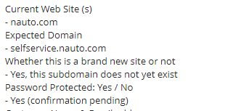
Example: they are live in selfservice.nauto.com, before it was in Nauto.com, which applies to forth case:
If migrating another domain, the old and the new domains should be hosted.
In this example, Nauto.com is not hosted, so I need to tell CPM to host this domain.
You can include on the mail: Domain: Nauto.com as it was the previous site should be hosted as “Secure Web Store”. This is created by CPM.

- Only the primary domain should be hosted as “Single Domain for Web Store and Checkout”.
- No domain should be hosted as “Redirect URL”
- Make sure that all domains are hosted correctly:
  - If secure, it should be hosted as “Secure Web Store” (excluding primary domain as we see before)
  - If non-secure, it should be hosted as “Web Store Only”
- In case you found a missing domain or an error, include it on the Post Go-Live email conclusion. (Si no hay errores, no incluyo nada)

Primary Domain:

- Go to Commerce / Websites / Websites List and select Edit in the corresponding website
- Go to Domains tab
- In the Shopping Domains list, make sure that the primary domain box is checked correctly. If not, contact CPM.

Sitemap:

Configure Sitemap generation:
- Go to Commerce / Marketing / Sitemap Generator
- Click Edit in the live domain
- In the Sitemap Content tab, into Pages to Generate, click on the checkbox “SMT Landing Pages”.
- In the Scheduling tab, click on the checkbox “Enable scheduling of sitemap generation”. In Frequency, select Weekly and Sunday.
- Click on Save.

Sitemap generation:
- Go to Commerce / Marketing / Sitemap Generator
- Click on the checkbox of the live URL
- Click on Generate Sitemap
- Reload page
- Click on Sitemap files. That file cabinet should include:
  - Index sitemap
  - Unique sitemap (the one with the ID)
  - Google verification file (add it from the local project folder)
- 

Submit Sitemap: (Estos son los pasos mencionados anteriormente).
- Go to Google Search Console (https://search.google.com/search-console/) (Aprieto continue habiendo puesto el sitio live y pongo continue y luego go to property)
- Go to Properties dropdown (top left) and select Add Property
- Inside the popup, in the URL Prefix field, paste the live domain i.e.: https://www.example.com/. Click on Continue.

- It will pop up the following screen:

This is the google verification file, which I have to add it to the file cabinet on the netsuite’s backend account, if I do not have it. This is done with each live site, and also this html file I have to add it on every local folder (for example: sites -> DX PS -> NAI or HCS, or any other project) and drive folder for this project.

Then, I add this file on file cabinet, on Web Site Hosting Files -> Live Hosting Files:

Once uploaded, i press verify:


Then:
- Inside the confirmation popup, click on Go to property.
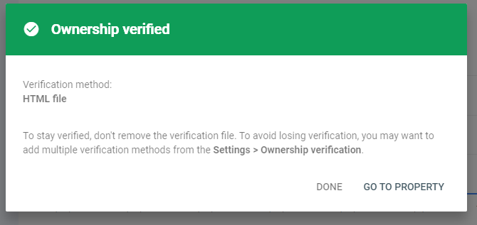
- Select Sitemap (left menu)
- 
- Copy the name of the Unique sitemap file (the one with the ID) from the file cabinet and paste it in Google Search Console, in Enter Sitemap URL field. Click on Submit. (Example: sitemap_www.thecoop.com_1667572278_1.xml)
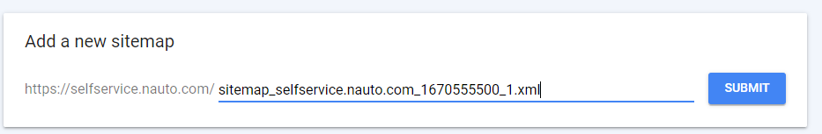
- Copy the name of the Sitemap Index file from the file cabinet and paste it in Google Search Console, in Enter Sitemap URL field. Click on Submit.
- Make sure that both sitemaps have the Success status
- Si no dice success, es probablemente porque el robots.txt esta como disallowed, al no permitir a ningún robot examinar, por eso no lo puede leer.
- Once everything is correctly set up, we should remove the Unique Sitemap file from the Submitted Sitemaps in Goole Search Console
- 
- El unique es el que tiene número, y dentro del de arriba de index, debería estar el unique, entro me fijo y está.
  - Click on the Unique Sitemap (entro en el marcado, y a la derecha tiene los 3 puntitos una vez que entre).
  - Go to the three black points located in the top right
  - Click on Remove Sitemap and the click on remove on the popup.

robots.txt:
- “Modify robots.txt to Disallow: / (DX)” we must confirm if robots.txt is configured to prevent the indexing of the site. Robots.txt should be configured as:
User-agent: *
Disallow: /
The status could appear as Done or Pending. If Done, nothing should be added. If Pending, we should add in a sub-bullet point the reason why it is not configured (i.e.: “Depends on backend access blocker”)

How to check robots.txt?
- Go to the implementation URL and add “/robots.txt” at the end
- If it says “Allow: ”, “Allow: /” o “Disallow: ” it is because it is not configured. If it appears as indicated above, it is correctly configured.

How to configure robots.txt?
- Go to customer NetSuite backend
- Documents / Files / File cabinet
- Click on Web Site Hosting Files.
- Click on Live Hosting Files
- Click on Add file (top left) and select the robots.txt file located on the local folder of the project. Import it. . (para password protected es siempre disallow /)
  - If customer has more that one site in the same NetSuite account, the robots.tx file for our project should be named “nameofthesite_robots.txt”. Then, we should create a redirect from “/robots.txt” to “nameofthesite_robots.txt”.
    - Go to Commerce / Hosting / Redirects and click on New.

- “Fill up support case on behalf of the customer requesting to “Enable Switch 17” to disable the SEO Engine only for this specific website record and not whole account. (FC or CPM)” we must confirm if Switch 17 is enabled. The status could appear as Done or Pending. If Done, nothing should be added. If Pending, we should add in a sub-bullet point the reason why it is not enabled (i.e.: “Depends on backend access blocker”).
How to check if Switch 17 is enabled?
      - Go to implementation URL
      - Open View Source
      - Add to the final of each URL this parameter: ?seodebug=T&preview=23456 (Preview number should be changed each time for a new random number)
      - Verify if SEO engine is not executed.
Aquí vemos que dice que no ha sido ejecutado, está bien.
Google Search Console and Google Analytics configuration:

Google Search Console:
Dentro de google search console.
If the Post Go Live Check succeeded, we should request the indexing of the pages.
- Go to URL Inspection (left menu) and paste the live site URL (https://www.example.com/). Click on Enter

- Click on Test Live URL (to make sure that Google is not checking a cache version)
- Presiono aquí:

- If everything appears as green (or grey if it is a new site) on the next window, click on Request indexing.

Acá estaba live en store.thecoop.com, entonces tenes que pedirle que indexe en www.thecoop.com.
- Click on Got it
Link the Google Search Console property to the Google Analytics property.
- Go to Settings (left menu) and click on Associations.
- Click on Associate and paste the Google Analytics Property ID to associate. Select the correct one and click on Continue
- Confirm the association

Provide the customer with access.
- Go to Settings (left menu) and click on Users and permissions.
- Go to the Google Tag Manager/Admin/User Management and copy user’s emails with access. (Missing for Nauto)
- Go back to Google Search Console and click on Add User. Paste the emails and provide them with:
  - Owner: if they are part of the company
  - Full: for other domains
  - Restricted: mails that in GTM don’t appear as Administrator.
- Click on Add

Google Analytics: Abro Google analytics

(esto ya lo habíamos hecho en el tracking tools integration, cuando viene de un sitio que muda al mismo dominio, no hay que hacer mucho, si hay que chequear la default URL si se cambian de un dominio a otro)

Set a note that indicates the go live date.
- Go to Audience / Overview (left menu)
- Make sure that the date range selector includes the go live date.
- Below the graphic, there is an arrow point down. Click there and then click on Create New Annotation.

- A date range selector will be displayed. Select the go live date
- On the text box, write “SC or SCA (what applies) Live”.
- Make sure that in the Visibility section, the Shared box is checked.
- Click on Save.

Verify and adjust Google Analytics configurations.

At Property level:
- Property Settings:
  - Property Name: We must check the name is appropriate according to the site/project we’re working on. DO NOT modify it if there´s more than one site being tracked
IE: If the name says “NetSuite Test” we should modify it for the project name or customer name
  - Default URL:
    - There´s a selector for http and https, which means: the second field MUST NOT contain the protocol. The second field is for the hostname (domain+subdomain, without trial slash and without protocol)
    - The configuration should be for the “new” site (so likely HTTPS, likely with WWW, etc) and may not necessarily match at 100% with the old domain´s configuration (might be http, might be root domain, etc).
    - If it’s a new site, just make sure to use the proper protocol and (sub)domain
  - Default View: do not modify if multiple sites are being tracked on the same property.
If there´s nothing selected: select the view that makes more sense – ideally one that´s not filtered.
  - Industry category: select the one that makes more sense. This is not mandatory though.
  - Enable Demographis and Interest reports: Yes, if possible
  - Enable User Metric in Reporting: Yes, if possible
  - Save.
- Tracking Info / Referral Exclusion List:
  - Check that the root domain is listed. For new properties/new domains, this is frequently automatic
  - To add a new root domain into it, hit the “+ Add Referral Exclusion” and type the root domain.
  - Add the other following excludable domains: netsuite.com, netsuitestaging.com which are in order to avoid referrals from those sources (frequently utilized for testing purposes)

At View level:
- View Settings:
  - View Name:
    - Check that the name makes sense for the project at hand. DO NOT modify if its being utilized for more than one site
  - Website´s URL:
    - This is for THE FINAL site. Select http or https, then type the host name (sub domain or domain, without protocol nor trial slash)
  - Time Zone country or territory.
    - By default Analytics will show US and GMT-08:00. We can keep it this way if we are unsure about customer´s timezone
  - Default Page:
    - always empty at this phase.
  - Exclude URL query parameters:
    - always empty at this phase.
  - Currency Displayed as:
    - By default we´ll see US Dollars. It should be like this in most cases.
  - Bot Filtering:
    - Always selected
  - Site Search Tracking:
    - Enable it.
      - Query Parameter: “keywords”
      - Strip query parameters out of URL: must NOT be enabled
  - Site Search Categories: must NOT be enabled
  - Click on Save

- Ecommerce Settings:
  - Enable Ecommerce:
    - Always enabled
  - Enable Enhanced Ecommerce Reporting:
    - Always enabled
  - Click on Save.

  - Mail closure:
We must indicate the project status. It could be:
- Site has (a) pending item(s) to be cleared after going live
- Site has no pending items and they are ready to go live

- Updating Task
Depending on the results of the Pre-Go Live checkpoint/ DX Action Items, you will update the job record as follows:
- No pending items
  - Next Step: Completed
  - Date Completed: this day
  - The task remains assigned to you

- Still pending items:
  - Next Step: Clear the pending items
  - Next Due Date: this day
  - Assignee: CPM


